Abstract
Economic Crisis Prediction: Improving the Trade-off Between Interpretability and Statistical Accuracy in ML-Enhanced Crisis Prediction Models
Pavlos Papachristos • PP24589 • MSc Artificial Intelligence, University of Essex Online • April 2026

This dissertation investigates the conditions under which machine learning-based early-warning systems (EWS) for banking crises fail, and why that failure is structural rather than technical. The central question is not whether sentiment augmentation improves crisis prediction, but whether the predictive gains observed under standard evaluation designs survive genuinely prospective validation — and what the answer implies for the EWS modelling framework itself.
The analysis extends a two-stage pipeline built on the JST Macrohistory Database R6 (Jordà, Schularick and Taylor, 2017) covering 18 advanced economies over 1989–2020. Stage 1 evaluates macro-only models — logistic regression (M1), Random Forest (M2), and an Explainable Boosting Machine (EBM, M2.5) — across 37 crisis events on the extended panel. Stage 2 evaluates XGBoost augmented with FinBERT central bank speech sentiment (M3) against macro baselines on 26 crisis events over 2003–2020. EBM is introduced as a natively interpretable non-linear benchmark whose fitted shape functions provide direct, post-hoc-free evidence about the feature-risk mapping learned by the model.
Four principal findings emerge. First, extending macro training history by fifteen years across multiple pre-GFC crisis episodes does not resolve the generalisation problem: M2 achieves AUROC 0.481 under strict temporal validation, below the random classifier threshold. Second, EBM achieves higher expanding-window metrics than both M2 and M3 (Stage 1 AUROC 0.753; Stage 2 AUPRC 0.532) but collapses more severely under prospective evaluation (AUROC 0.333), consistent with greater representational flexibility increasing vulnerability to regime-specific overfitting, even in natively interpretable models. Third, EBM shape functions — estimated separately on pre-GFC and GFC-inclusive training windows — are qualitatively distinct across regimes, making the learned feature-risk instability directly visible without any post-hoc attribution approximation. Fourth, FinBERT sentiment contributes a directional but statistically unconfirmed AUPRC increment (6.8 percentage points, 95% CI spanning zero) that cannot be confidently attributed to a stable sentiment signal because performance differences are at least as sensitive to model class as to the sentiment feature extension.
Taken together, these findings indicate that the failure of machine learning-based EWS is not primarily a function of model choice, feature design, or data availability, but of a deeper structural instability in the mapping between predictors and crisis outcomes across regimes — a limitation that was not resolved in this study through additional data, model complexity, or interpretability enhancements.

Chapter 1: Introduction

1.1 Background and Motivation
The failure to anticipate systemic banking crises carries severe economic consequences. The Global Financial Crisis of 2007–2009 exposed critical gaps in the analytical frameworks used by supervisory authorities to monitor financial system stability (Laeven and Valencia, 2020). Despite substantial research effort, the fundamental challenge remains: how to construct models that identify systemic risk build-up far enough in advance to permit effective policy intervention, and that remain reliable across structurally different crisis configurations.
The early-warning system (EWS) literature has evolved through two phases. The first, associated with Kaminsky, Lizondo and Reinhart (1998) and Demirgüç-Kunt and Detragiache (1998), relied on simple statistical models applied to macroeconomic indicators. The second introduced machine learning methods — Random Forest, XGBoost — that improved discrimination metrics within standard expanding-window evaluation designs (Beutel, List and von Schweinitz, 2019). However, reliability deteriorated under strict temporal validation: models trained exclusively on pre-crisis data consistently failed to meet the 0.75 AUROC benchmark for practically useful prediction.
A parallel development introduced textual data from central bank communications as a complementary signal. Sentiment extraction from BIS speeches using FinBERT (Yang, Uy and Huang, 2020) operationalises this channel systematically. Both developments raise a common question: under what conditions do the observed performance gains survive genuinely prospective testing, and what does the answer reveal about the EWS modelling framework? This dissertation addresses that question using an extended macro panel, a natively interpretable non-linear model, and strict temporal validation.

1.2 Research Problem
The research problem has two analytically distinct dimensions. The first is methodological: standard expanding-window cross-validation allows training folds to accumulate crisis-period data, producing metrics that overstate prospective predictive performance — a problem particularly severe in GFC-concentrated datasets. The second is theoretical: the data-generating process that produces crisis outcomes may not be stationary across time. Models trained on one crisis type learn a mapping that does not generalise to structurally different episodes, regardless of training sample length or algorithm sophistication.

1.3 Aim, Objectives and Hypotheses
Research Aim: To investigate the extent to which ML-based EWS achieve genuinely prospective predictive performance, and to characterise the structural conditions under which their generalisation fails, using an interpretable non-linear benchmark that makes the failure mechanism directly visible.
Objectives: (O1) Extend the JST panel from 2003–2020 to 1989–2020 incorporating multiple pre-GFC episodes; (O2) evaluate a model sequence — M1 (logistic regression), M2 (Random Forest), M2.5 (EBM), M3 (XGBoost + FinBERT) — under consistent expanding-window and strict temporal validation; (O3) use EBM shape functions to provide direct evidence on whether the learned feature-risk mapping is regime-stable; (O4) assess the incremental contribution of FinBERT sentiment controlling for the algorithm effect; (O5) evaluate ensemble averaging under single-episode evaluation constraints; (O6) draw implications for EWS design and ML under distribution shift.
Hypotheses: H1 — M3 achieves higher AUROC/AUPRC than M2-matched within Stage 2. H2 — at least one FinBERT feature ranks in the top five by SHAP attribution. H3 — a quantifiable accuracy-interpretability trade-off exists across M1 → M2 → M3. EBM extends H3 by testing whether interpretability and accuracy can be jointly achieved within the non-linear class.

1.4 Contribution
The dissertation makes four contributions. Empirical: extending training history across diverse crisis episodes does not resolve prospective generalisation failure. Methodological: quantifying the evaluation bias in expanding-window designs by comparing OOS metrics against strict temporal results. Interpretability: EBM shape functions expose regime-specific misspecification directly, without post-hoc attribution approximation. Theoretical: EBM’s stronger prospective collapse relative to Random Forest provides evidence that the EWS failure is structural rather than simply a consequence of model opacity — placing the problem within the ML literature on distribution shift.

1.5 MSc AI Requirement
This dissertation implements and critically evaluates three ML model classes — gradient-boosted trees (XGBoost), ensemble methods (Random Forest), and gradient-boosted GAMs (EBM) — alongside a transformer-based NLP pipeline (FinBERT). The analysis of distribution shift and non-stationarity connects to fundamental questions in learning theory. The project applies expanding-window CV, bootstrap CIs, Granger causality, SHAP, and EBM shape function analysis, and uses exclusively publicly available secondary data with ethical review clearance (low risk, no human participants). Code is available at https://github.com/spike2025-art/eportfolio-uoe/tree/main and the ePortfolio at https://spike2025-art.github.io/eportfolio-uoe/.

1.6 Dissertation Structure
Chapter 2 reviews the EWS, interpretability, central bank text, and ensemble literatures. Chapter 3 describes the research design, data, models, and evaluation framework. Chapter 4 presents results across all model specifications. Chapter 5 discusses findings and implications. Chapter 6 states conclusions and recommendations. References and appendices follow.

ChatG review:

This dissertation investigates why machine learning-based early-warning systems (EWS) for banking crises fail under genuinely prospective validation. Rather than asking only whether sentiment augmentation improves crisis prediction, the study examines whether performance gains observed under standard expanding-window evaluation survive strict temporal testing, and what this reveals about the EWS modelling framework.
The analysis extends a two-stage pipeline built on the JST Macrohistory Database R6 (Jordà, Schularick and Taylor, 2017), covering 18 advanced economies over 1989–2020. Stage 1 evaluates macro-only models — logistic regression (M1), Random Forest (M2), and an Explainable Boosting Machine (EBM, M2.5) — across 37 crisis events. Stage 2 evaluates XGBoost augmented with FinBERT central bank speech sentiment (M3) against macro baselines on 26 crisis events over 2003–2020. EBM is introduced as a natively interpretable non-linear benchmark whose fitted shape functions provide direct, model-native evidence about the feature-risk mapping learned by the model.
Four findings emerge. First, extending macro training history by fifteen years across multiple pre-GFC crisis episodes does not resolve the generalisation problem: M2 achieves AUROC 0.481 under strict temporal validation, below the random-classifier benchmark of 0.5. Second, EBM achieves higher expanding-window metrics than both M2 and M3, including Stage 1 AUROC 0.753 and Stage 2 AUPRC 0.532, but collapses more severely under prospective evaluation, with AUROC 0.333. This is consistent with the possibility that greater representational flexibility increases vulnerability to regime-specific overfitting, even in interpretable models. Third, EBM shape functions estimated separately on pre-GFC and GFC-inclusive windows are qualitatively different, making feature-risk instability directly visible without post-hoc attribution. Fourth, FinBERT sentiment produces a directional AUPRC gain of 6.8 percentage points, but the confidence interval spans zero and the gain cannot be cleanly separated from model-class effects.
Overall, the findings indicate that ML-based EWS failure is not primarily a function of model choice, feature design, or data availability, but of structural instability in the mapping between predictors and crisis outcomes across regimes. In this study, that limitation was not resolved through additional data, model complexity, or interpretability enhancements.

‘’’’’’’’’’’’’’’’’’’’’’’’’’’’’’’’’’’’’’’’’’’’’’’’’’’’’’’’’’’’’’’’’’’’’’’’’’’’’’’’’’’’’’’’’’’’’’’’’’’’’

Chapter 2: Literature Review

2.1 Early-Warning Systems for Banking Crises
The early-warning system literature originated with signal extraction approaches (Kaminsky, Lizondo and Reinhart, 1998) and logistic regression frameworks (Demirgüç-Kunt and Detragiache, 1998), establishing the binary prediction paradigm that subsequent machine learning work extended. The landmark contribution of Schularick and Taylor (2012) demonstrated that credit booms are the single strongest predictor of systemic banking crises across a long historical panel, motivating the macro feature sets — credit aggregates, interest rate spreads, asset prices — standard in subsequent EWS research. The JST Macrohistory Database (Jordà, Schularick and Taylor, 2017), the primary data source for this dissertation, assembles these series for eighteen advanced economies from 1870 to 2020, enabling evaluation across structurally diverse pre-GFC episodes.
A critical limitation of the macro EWS framework is its implicit stationarity assumption: that the mapping between precursors and crisis outcomes is stable across time. The heterogeneity of crisis mechanisms — domestic credit-boom collapses, contagion events, speculative attacks (Obstfeld, 1996), and exogenous shocks — implies that no single feature set is universally predictive. Laeven and Valencia (2020) document significant cross-episode variation in systemic banking crisis characteristics, confirming that undifferentiated crisis labels conflate structurally distinct events. This non-stationarity assumption is the theoretical foundation for the strict temporal validation central to Chapter 4.

2.2 Machine Learning in Crisis Prediction
Alessi and Detken (2018) demonstrated that Random Forest models outperform logistic regression on standard EWS metrics. Beutel, List and von Schweinitz (2019) conducted the most comprehensive ML evaluation to date, finding consistent AUROC gains from machine learning over logistic regression within expanding-window designs — but documenting substantial deterioration under genuinely prospective evaluation. Their AUROC benchmark of 0.75 serves as the threshold for practically useful EWS performance in this dissertation’s temporal validation.
Under the class imbalance characteristic of crisis datasets (5–10 per cent positive rate), the choice of evaluation metric substantially affects conclusions. Davis and Goadrich (2006) demonstrate that AUPRC is more informative than AUROC under high class imbalance, being more sensitive to improvements in crisis detection at the threshold values relevant for policy. Saito and Rehmsmeier (2015) confirm this formally. Both metrics are reported throughout; AUPRC is treated as primary in Stage 2.

2.3 Central Bank Communication and Text Analysis
The BIS Central Bank Speech Archive provides a consistent multilingual corpus spanning over two decades for the countries in the EWS panel. FinBERT (Yang, Uy and Huang, 2020), a BERT-based model fine-tuned on financial communications, provides sentence-level sentiment classification used in this dissertation to construct country-year sentiment features from 16,622 speeches. Central bank language — characterised by hedged, indirect formulations — presents a specific domain challenge: aggregate sentiment polarity captures less than the topic-specific dimensions of systemic risk concern identified by Ho, Moench and Steeley (2022), who show that prevalence measures for credit risk discussion provide more stable predictive signals than polarity scores. Loughran and McDonald (2011) established the more general principle that domain-specific lexicons substantially outperform general sentiment tools on financial text. Both findings motivate the topic-specific extension proposed in Chapter 5.

2.4 Interpretability in Machine Learning
The interpretability-accuracy trade-off is a central tension in applying machine learning to high-stakes domains. SHAP (Lundberg and Lee, 2017) provides post-hoc attribution for non-linear models using Shapley values from cooperative game theory, with exact computation for tree-based models via TreeSHAP. Despite wide adoption, Hooker and Mentch (2019) demonstrate that permutation-based methods including SHAP can produce misleading attributions under feature correlation — a particular concern in macro panels with strong multicollinearity. SHAP attributions should therefore be interpreted as measures of model re-weighting rather than causal economic importance.
Explainable Boosting Machines (Lou, Caruana, Gehrke and Hooker, 2013) represent an alternative: a gradient-boosted GAM that learns univariate shape functions and pairwise interactions, whose outputs are exact representations of what the model has learned rather than post-hoc approximations. Because shape functions are the model itself, instability in those functions across different training periods reflects a property of the fitted model rather than attribution approximation error, and provides evidence of instability in the underlying data-generating process — a property that is central to the regime instability analysis in Section 4.7.

2.5 Ensemble Methods and Financial Contagion
Holopainen and Sarlin (2017) formalised the motivation for ensemble averaging in EWS settings: combining predictions across classifiers with different architectures consistently outperforms single-model selection under small-sample, crisis-concentrated evaluation, with the improvement largest when component disagreement is highest at crisis observations. Equal-weighted averaging is used in this dissertation to avoid the circular weight-selection problem of using OOS performance to derive weights.
The cross-country financial linkages through which GFC stress propagated — documented via bank balance sheet network data by Cetorelli and Goldberg (2011) — are absent from the present feature set, which treats each country independently. This structural gap is consistent with the model’s weaker performance for contagion-driven crises (Germany, Belgium, Switzerland in 2007–2008) and is identified as the most ambitious future extension in Chapter 5.

2.6 Research Gap
Three specific gaps motivate this dissertation. First, the behaviour of EBM under strict temporal validation — and whether interpretable models are more or less susceptible to regime-specific overfitting — has not been examined in the EWS literature. Second, existing studies document prospective failure without providing a mechanism-level explanation; EBM shape functions enable direct observation of which feature-risk relationships break down across regime boundaries. Third, sentiment-augmented EWS studies do not control for the algorithm effect — the possibility that performance gains attributed to sentiment reflect the algorithm switch rather than the sentiment signal itself. EBM on the same macro features as M2 isolates this effect.

Chapter 3: Methodology

3.1 Research Design
This dissertation adopts a quantitative empirical research design using secondary panel data. The strategy is explanatory: to characterise the conditions under which ML-based EWS succeed and fail, and to use an interpretable model class to make the failure mechanism directly visible. The framework is a two-stage augmented pipeline. Stage 1 evaluates macro-only models on a 1989–2020 extended panel across multiple pre-GFC crisis episodes. Stage 2 evaluates sentiment-augmented models on the 2003–2020 overlap window where FinBERT data is available.

3.2 Data Sources and Ethics
JST Macrohistory Database R6 (Jordà, Schularick and Taylor, 2017) covers 18 advanced economies from 1870–2020. After three-year lag construction, the usable Stage 1 panel is 569 country-year observations (1989–2020). Two minor data gaps were addressed by linear interpolation (Denmark government debt, 1997; Portugal house prices eliminated by lag construction).
BIS Central Bank Speeches: 16,622 speeches (2003–2020) across 18 countries were downloaded from the BIS archive, matched to country identifiers, and processed through FinBERT (ProsusAI/finbert) running approximately 12.4 hours on CPU. Speech-level sentiment scores were aggregated to country-year level by length-weighted mean. Full pipeline in notebooks NB03–NB04.
Ethics: Exclusively publicly available secondary data. No human participants. Ethics review: low risk, no further action required. Random seeds fixed at 42 throughout. Full code at https://github.com/spike2025-art/eportfolio-uoe/tree/main; ePortfolio at https://spike2025-art.github.io/eportfolio-uoe/.

3.3 Target Variable and Features
The primary target target_h2 marks a country-year positive if crisis onset falls within the following two years (37 positives at 6.5% in Stage 1; 26 at 8.15% in Stage 2). COVID-19 (2020) is excluded from the crisis chronology; the observation is retained in the held-out set.
Macro features (41): Ten JST variables (credit aggregates, house prices, interest rates, monetary aggregates, government debt, CPI, current account, real GDP) at lags 1–3, plus term spread, growth rates, and rolling credit trend measures. All expanding-mean demeaned using country-specific means from prior years only, preventing forward leakage.
Sentiment features (20): Six FinBERT measures (P_pos, P_neg, P_neutral, net_sentiment, annual changes) at lags 1–2 plus rolling derivatives, three-year rolling-window demeaned.

3.4 Model Specifications
Model | Algorithm | Features | Key settings
M1 | Logistic Regression | 19 (lag1 only) | L2 C=0.1, balanced weights
M1b | Logistic Regression | 41 (lag1–3) | Bridge specification
M2 | Random Forest | 41 macro | 500 trees, depth 5, balanced weights
M2.5 (EBM) | Explainable Boosting Machine | 41 macro | 5,000 rounds, 5 interactions, sample weights, no isotonic calibration
M3 | XGBoost + FinBERT | 61 (macro + sent) | 300 trees, depth 4, isotonic calibration (CalibratedClassifierCV)
M2-matched / M2.5-matched | RF / EBM | 41 macro | Trained on 2003–2020 only
Table 3.1. Model specifications summary.
Class imbalance is handled by per-fold sample weights: fold_spw = n_neg / n_pos applied within each expanding-window training fold. EBM uses the interpret package v0.7.8.

3.5 Evaluation Framework
Expanding-window CV: Stage 1 uses 26 evaluation folds (1993–2018) with a four-year burn-in; Stage 2 uses 12 folds (2007–2018). Years 2019–2020 are held out in both stages. OOS predictions are pooled for aggregate metric computation.
Strict temporal validation (the primary prospective test) trains exclusively on pre-crisis data: Split A (Pre-Nordic: 1988–1990 → 1991–1997) and Split B (Pre-GFC: 1988–2002 → 2003–2011). Split C (2003–2005 → 2006–2009) is infeasible due to zero training positives.
LOCO validation holds out each country in turn across 15 countries with hold-out crisis events (AUS, CAN, NOR excluded — no hold-out positives).
Metrics: AUROC (benchmark 0.75; Beutel, List and von Schweinitz, 2019); AUPRC (primary under class imbalance; Davis and Goadrich, 2006; Saito and Rehmsmeier, 2015); Brier Score (squared probability error); ECE (bin-level calibration). Bootstrap 95% CIs from 1,000 resamples are indicative only due to panel dependence.

3.6 EBM Shape Function Analysis and Ensemble Design
To test regime stability, EBM is fitted separately on two sub-periods — Pre-GFC (2003–2006) and GFC-inclusive (2003–2010) — and shape functions compared for term spread and credit across all three lag horizons. Instability in shape functions reflects properties of the fitted model rather than attribution approximation, and provides evidence of instability in the underlying data-generating process.
Two ensembles use equal-weighted OOS probability averaging (performance-weighted schemes are circular when weights are derived from the same OOS pool): E1-Orig (M4) = avg(M2-matched, M3) and E1-EBM = avg(M2-matched, M2.5-matched). Model disagreement is quantified as mean absolute difference between component probabilities separately at crisis and non-crisis observations.
The full notebook pipeline (NB00–NB09B) is documented in Appendix A.

Chapter 4: Results and Interpretation

4.1 Dataset and Experimental Setup
The purpose of this chapter is not to establish predictive superiority of sentiment-augmented models over macro baselines in any general sense. It is to demonstrate the extent to which apparent performance gains depend on evaluation design under severe data constraints, and to characterise precisely where those gains arise, under what conditions they survive, and why they should be interpreted with caution. This framing governs all result interpretation throughout — including the EBM results introduced in this chapter — because the evaluation constraints established here apply with equal force to all models regardless of their algorithmic sophistication or interpretability properties.
The analysis adopts a two-stage design that extends the original 2003–2020 macro panel backwards to 1985, using the JST Macrohistory Database R6 (Jordà, Schularick and Taylor, 2017). Stage 1 covers the macro-only models (M1, M1b, M2 and M2.5) on the full extended panel spanning 1985–2020. After three-year lag construction eliminates the 1985–1987 warm-up rows, the usable dataset comprises 569 country-year observations from 18 advanced economies over 1989–2020. The primary prediction target, target_h2, marks a country-year positive if a systemic banking crisis onset falls within the following two years, yielding 37 positive observations against 532 negative and a base rate of 6.5 per cent. The extension period (1989–2002) contributes 11 positives from the Nordic banking crisis cluster and further country-events; the 2003–2020 period contributes the remaining 26. Stage 2 covers M2-matched, M2.5-matched and M3 on a 2003–2020 overlap window with 26 positives and a base rate of 8.15 per cent. Two minor data gaps were addressed by linear interpolation (Denmark government debt, 1997) or were eliminated by the lag construction (Portugal house prices, 1985–1987).
Feature engineering follows the same procedure as the original analysis. Macro features are demeaned using expanding country-specific means, ensuring no forward leakage. M1 is logistic regression on 19 features at lag one only. M2 and M2-matched are Random Forests on 41 macro features at lags one through three. M3 is XGBoost on 61 features extending M2-matched with 20 rolling-demeaned FinBERT sentiment features; isotonic probability calibration is applied via CalibratedClassifierCV within each expanding-window fold. M2.5 (EBM) is an Explainable Boosting Machine (Lou et al., 2013) trained on the same 41 macro features as M2. EBM is a gradient-boosted generalised additive model that learns univariate shape functions for each feature and up to five pairwise interaction terms, producing a natively interpretable model whose feature contributions can be read directly from fitted shape plots without post-hoc attribution. Inverse-frequency sample weights handle class imbalance. Expanding-window cross-validation for Stage 1 uses a four-year burn-in from 1989 with 26 evaluation folds (1993–2018); Stage 2 uses a four-year burn-in from 2003 with 12 evaluation folds (2007–2018); 2019 and 2020 are held out in both stages.
Two methodological constraints govern all interpretation throughout. First, Stage 2 AUPRC is computable in one fold only (crisis events concentrate in 2007); Stage 2 results constitute a Cross-Sectional Case Study of the 2007 GFC, measuring in-crisis discrimination across 18 countries rather than temporal predictive validity. All Stage 2 performance figures should be read as in-crisis discrimination measures, not out-of-sample predictive evidence. Second, all models fall substantially below the 0.75 AUROC benchmark under prospective evaluation (Section 4.5); all expanding-window metrics are upper bounds on prospective performance.

4.2 Primary Model Comparison
Table 4.1 presents Stage 1 post-calibration metrics for M1, M1b, M2 and M2.5 (EBM) on the extended panel. Table 4.2 presents Stage 2 metrics for M2-matched, M2.5-matched, M3 and M4. Bootstrap 95 per cent confidence intervals from 1,000 resamples are indicative only.

Table 4.1. Stage 1 — Model comparison on extended macro panel (H2 target, 1989–2020)
Model | Features | AUROC | 95% CI | AUPRC | AUPRC/Base | Brier
M1: Logistic Regression (macro lag1) | 19 | 0.606 | [0.477, 0.739] | 0.139 | 2.1× | 0.157
M1b: LR bridge (macro lag1–3) | 41 | 0.646 | — | 0.145 | 2.2× | 0.136
M2: Random Forest (macro lag1–3) | 41 | 0.636 | [0.484, 0.781] | 0.224 | 3.4× | 0.060
M2.5: EBM (macro lag1–3) | 41 | 0.753 | [0.649, 0.855] | 0.273 | 4.2× | 0.064
Table 4.1. Stage 1 evaluation metrics on H2 (2-year) target. Events: 37/569 (6.5% base rate). CI: 1,000 bootstrap resamples; indicative only given multi-episode evaluation and panel dependence. Stage 1 covers 1989–2020; 26 evaluation folds. All metrics are upper bounds on prospective performance (Section 4.5). M2.5 uses identical features and CV design as M2; the magnitude of EBM’s apparent advantage is subject to the same regime-specific evaluation bias that inflates all expanding-window figures.

Table 4.2. Stage 2 — Model comparison on sentiment overlap period (H2 target, 2003–2020)
Model | Features | AUROC | 95% CI | AUPRC | AUPRC/Base | Brier
M2-matched: RF (macro lag1–3) | 41 | 0.939 | [0.897, 0.970] | 0.343 | 4.2× | 0.060
M2.5-matched: EBM (macro lag1–3) | 41 | 0.960 | [0.927, 0.988] | 0.532 | 6.5× | 0.067
M3: XGBoost + FinBERT (macro + sent) | 61 | 0.932 | [0.875, 0.979] | 0.411 | 5.0× | 0.061
M4: Ensemble avg(M2-matched, M3) | — | 0.943 | [0.895, 0.979] | 0.440 | 5.4× | 0.057
Table 4.2. Stage 2 evaluation metrics on H2 (2-year) target. Events: 26/319 (8.15% base rate). Per-fold AUPRC computable in one fold (2007) only — metrics represent cross-sectional discrimination within a single episode. Bootstrap 95% CI for AUPRC difference (M3 − M2-matched): [−0.130, +0.312]. M2.5-matched apparent advantages reflect more aggressive fitting of the GFC-dominated training distribution rather than superior generalisable predictive performance — the evaluation constraints of Section 4.1 apply to all models equally. All AUROC and AUPRC figures in this table are measures of in-crisis discrimination within the 2007 GFC episode and should not be interpreted as evidence of generalised prospective predictive performance.

Figure 4.1 presents ROC and PR curves for all models across both stages. The Stage 1 curves (solid) confirm that M2.5 appears to achieve a higher true positive rate at low false positive rates than M2 on the extended panel; Stage 2 dashed curves cluster at high AUC values for all models, reflecting GFC concentration. The PR curves show the wider dispersion of Stage 1 results — where multi-episode evaluation produces more realistic performance estimates — against the compressed Stage 2 figures.
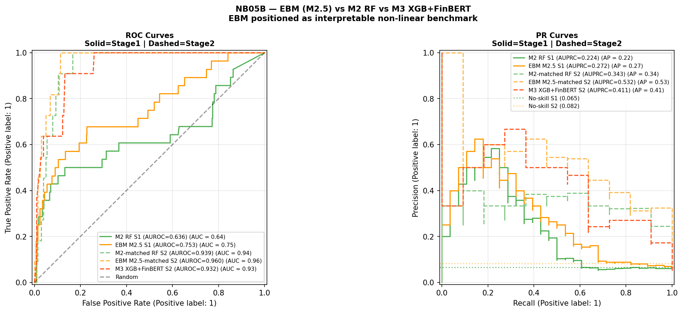

Figure 4.1. ROC and PR curves for all models across Stage 1 (solid lines) and Stage 2 (dashed lines). Stage 1: 37 crisis events, 1989–2020. Stage 2: 26 crisis events, 2003–2020. No-skill baselines shown as dotted horizontal lines. All metrics are upper bounds on prospective performance. The apparent Stage 2 superiority of M2.5-matched (orange dashed) is conditional on the single-episode GFC evaluation setting.
Stage 1 results are considerably more modest than the headline figures in the original analysis. M2 achieves AUROC 0.636 and AUPRC 0.224, a 3.4× AUPRC lift, compared with AUROC 0.947 and AUPRC 0.561 in the original — a collapse that reflects both the structural diversity of the extended multi-episode panel and the 26-fold evaluation window covering multiple economic regimes. M2.5 (EBM) appears to achieve AUROC 0.753 and AUPRC 0.273, the highest point estimates of any Stage 1 model, despite using identical features and an identical CV design. The AUROC gap of 0.117 has partially overlapping confidence intervals and is not statistically confirmed. The magnitude of EBM’s apparent advantage is itself likely inflated by the same regime-specific evaluation bias identified throughout this chapter: an algorithm with higher representational flexibility fits the GFC-dominated training distribution more precisely as later folds accumulate, producing higher OOS metrics in precisely the evaluation setting where all models are known to overfit the crisis regime.
Stage 2 metrics are broadly comparable to the original analysis. M2-matched achieves AUROC 0.939 and AUPRC 0.343. M3 achieves AUROC 0.932 and AUPRC 0.411, a 5.0× lift. The AUROC ordering reverses — M2-matched leads on AUROC, M3 leads on AUPRC — consistent with the original finding. Under the class imbalance present in Stage 2, AUPRC is the more informative metric (Davis and Goadrich, 2006) and is treated as primary. The AUPRC advantage of M3 over M2-matched is 6.8 percentage points, with bootstrap 95 per cent CI [−0.130, +0.312] spanning zero. However, this comparison confounds two variables simultaneously: the algorithm (Random Forest versus XGBoost) and the feature set (macro-only versus macro plus sentiment). The more informative test for H1 is the comparison between M2.5-matched (EBM, macro-only, AUPRC 0.532) and M3 (XGBoost, macro plus sentiment, AUPRC 0.411): M2.5 achieves markedly higher AUPRC without any sentiment features whatsoever. This suggests that the observed Stage 2 performance differences are at least as sensitive to model class as to the sentiment feature extension; the current design cannot cleanly isolate sentiment’s independent contribution because EBM and XGBoost also differ in regularisation, interaction handling, and calibration behaviour. The observed M3 advantage over M2-matched cannot be attributed to a stable or generalisable sentiment contribution with confidence, but neither can it be conclusively attributed to algorithm choice alone. This does not negate the directional AUPRC gain of M3 over M2-matched, but it substantially qualifies its interpretation as evidence of sentiment value.

Figure 4.2 presents the temporal probability plots for all models. EBM (orange) tracks near zero through the pre-GFC period before rising sharply at the 2007–2008 crisis peak and assigning the highest pre-crisis mean probability of any Stage 2 model in 2006. This temporal pattern is consistent with EBM’s shape functions fitting a sharper non-linear threshold; whether it reflects genuine crisis signal or more aggressive regime-specific fitting cannot be resolved within the expanding-window design.
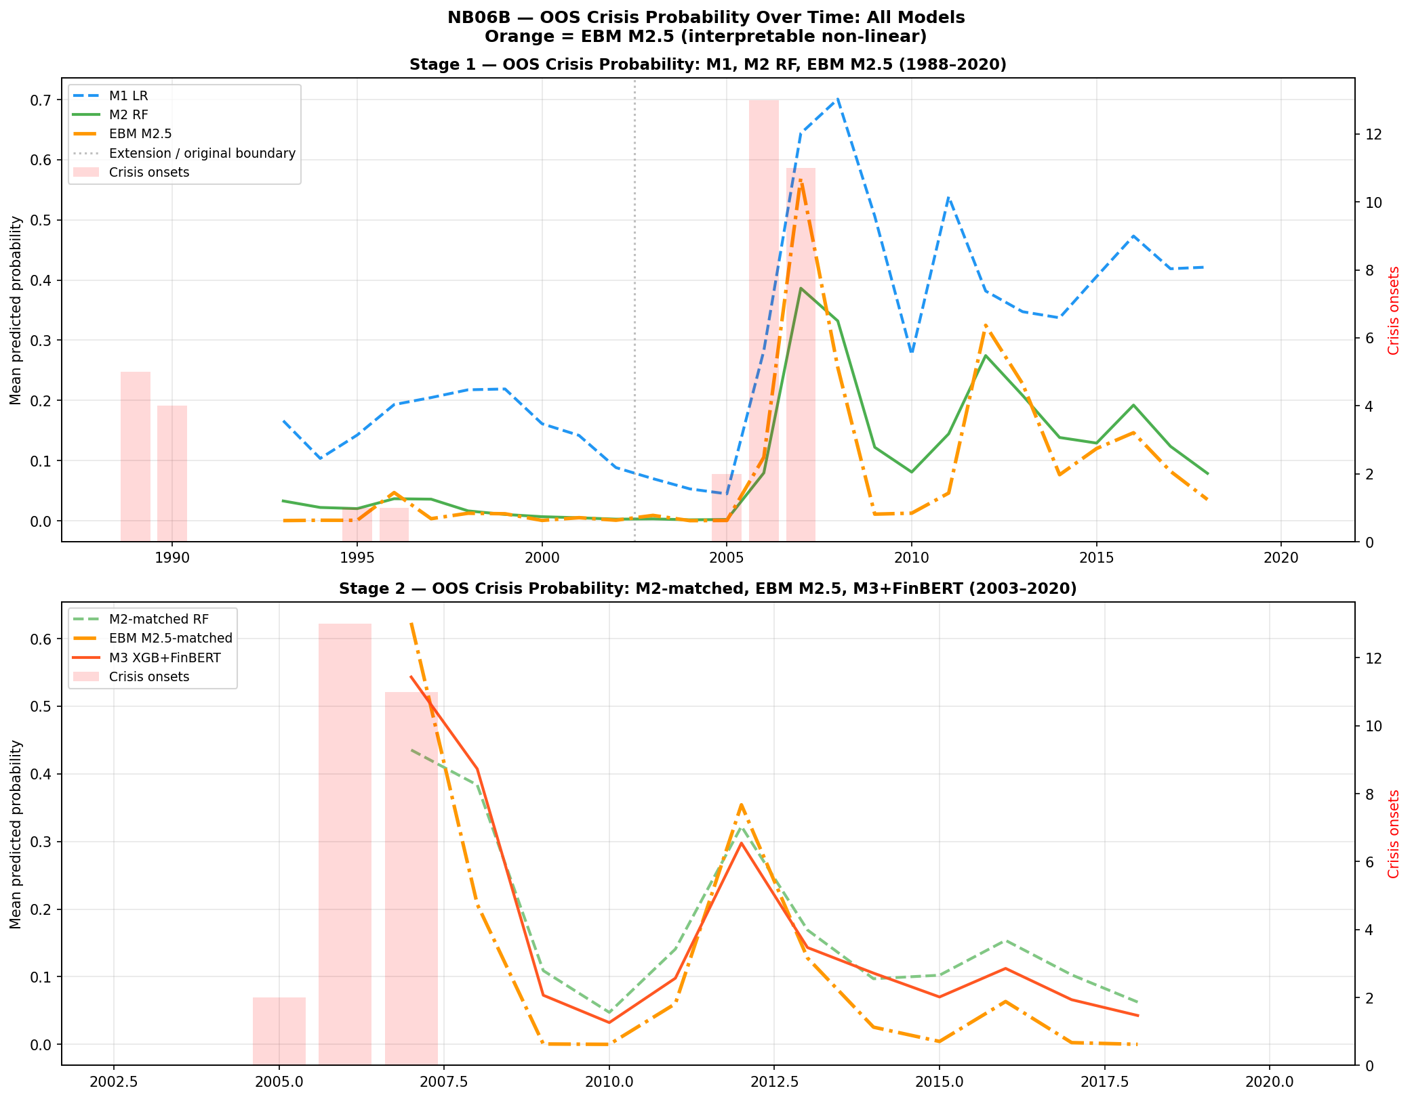
Figure 4.2. Out-of-sample crisis probability over time for all models. Stage 1 (top): M1 LR (blue dashed), M2 RF (green solid), EBM M2.5 (orange dash-dot), 1988–2020. Stage 2 (bottom): M2-matched RF (green dashed), EBM M2.5-matched (orange dash-dot), M3 XGB+FinBERT (red solid), 2003–2020. Red bars = crisis onset years. Dotted vertical line = extension/original period boundary.

H1 supported directionally on AUPRC: M3 0.411 versus M2-matched 0.343 within the 2007 GFC Cross-Sectional Case Study. The more informative comparison — M2.5 EBM (macro-only, AUPRC 0.532) versus M3 (macro plus sentiment, AUPRC 0.411) — suggests Stage 2 differences are at least as sensitive to algorithm class as to the sentiment extension. Bootstrap 95% CI [−0.130, +0.312] spans zero; all figures are in-crisis discrimination measures, not generalised prospective performance.
A model averaging extension, designated M4, is introduced following Holopainen and Sarlin (2017) as the equal-weighted average of M2-matched and M3 OOS probabilities. M4 achieves AUROC 0.943, AUPRC 0.440, and Brier Score 0.057 within the Stage 2 cross-sectional evaluation. An EBM-based ensemble extension is presented in Section 4.10.

4.3 Exploratory Decomposition of Model Changes
Table 4.3 extends the M1-to-M2 decomposition to include M2.5, making the full model sequence explicit. The M2 → M2.5 transition holds the feature set constant (41 macro features) while varying the algorithm, isolating the algorithm effect under identical data conditions.

Table 4.3. Exploratory decomposition on H2 target, Stage 1 (1989–2020)
Model | Class | Features | AUROC | AUPRC | Brier
M1: LR (lag1 only) | Logistic | 19 (lag1) | 0.606 | 0.139 | 0.157
M1b: LR (lag1–3) | Logistic | 41 (lag1–3) | 0.646 | 0.145 | 0.136
M2: RF (lag1–3) | Random Forest | 41 (lag1–3) | 0.636 | 0.224 | 0.060
M2.5: EBM (lag1–3) | EBM | 41 (lag1–3) | 0.753 | 0.273 | 0.064
Table 4.3. Exploratory decomposition, Stage 1. Base rate = 0.065. Transitions are not orthogonal treatments. All metrics are upper bounds on prospective performance.

The lag component (M1 to M1b) produces modest AUPRC gains (0.139 to 0.145). The non-linearity component (M1b to M2) produces a larger AUPRC increase (0.145 to 0.224) alongside a small AUROC decline, indicating that Random Forest adds precision-recall performance without uniformly improving rank-order discrimination. The algorithm component (M2 to M2.5) shows the largest apparent single-step AUROC gain in the sequence (+0.117), with M2.5 also showing higher point estimates on AUPRC (+0.049). Within the constrained evaluation setting, the M2 → M2.5 step involves a shift to a natively interpretable algorithm that achieves higher point estimates than its black-box counterpart. Whether this apparent gain survives genuinely prospective evaluation is answered in Section 4.5 — it does not.

H3 — Interpretability trade-off: Supported, but refined. The M1-to-M2 transition is associated with AUPRC gains at H2 (+0.085) at the cost of native log-odds transparency. Within the expanding-window evaluation, the M2-to-M2.5 transition demonstrates that an interpretable model can appear to achieve higher point estimates than its black-box counterpart on both primary metrics. The trade-off is therefore not binary within the non-linear model class — but this refinement does not alter the central conclusion that neither interpretability nor algorithm choice resolves the regime instability problem, as demonstrated in Section 4.5.

4.4 Multi-Horizon Analysis

Alternative prediction horizons (H1, H3) cannot be evaluated on the Stage 2 dataset: the held-out evaluation period contains insufficient positive crisis cases under all three horizon definitions, a structural consequence of crisis concentration in 2007. The original multi-horizon findings are noted for completeness and treated as preliminary observations specific to the original GFC-concentrated analysis.

4.5 Robustness: Temporal Validation and Leave-One-Country-Out

4.5.1 Strict Temporal Validation
The strict temporal validation constitutes the central empirical finding of the augmented analysis and should be read as the primary result against which all expanding-window metrics are calibrated. Table 4.4 presents results for both M2 (Random Forest) and M2.5 (EBM).

Table 4.4. Strict temporal validation — M2 RF and M2.5 EBM (macro lag1–3)
Split | Train | Test | Train pos. | Test pos. | M2 RF AUROC | EBM AUROC | Benchmark
A: Pre-Nordic | 1988–1990 | 1991–1997 | 5 | 1 | 0.572 | 0.752 | 0.75
B: Pre-GFC extended | 1988–2002 | 2003–2011 | 6 | 13 | 0.481 | 0.333 | 0.75
C: Pre-GFC short | 2003–2005 | 2006–2009 | 0 | — | — | — | —
Table 4.4. Strict temporal validation. Literature AUROC benchmark = 0.75 (Beutel, List and von Schweinitz, 2019). Split C skipped: zero training positives. Split A: one positive test case — not a distributional estimate, reported for completeness only. Split B is the substantive prospective result. Neither model meets the 0.75 benchmark in Split B. EBM collapses more severely than RF in Split B.

Split B is the substantive finding. M2 RF achieves AUROC 0.481, below random. M2.5 EBM achieves AUROC 0.333 — substantially below random and below the RF result. This constitutes the most informative empirical finding in the chapter: the model that achieves the highest expanding-window metrics fails most severely under genuine prospective evaluation. The stronger collapse of EBM under prospective conditions is itself analytically important: models with higher representational flexibility may overfit regime-specific structures more aggressively, even when those models are natively interpretable. EBM’s gradient-boosted shape functions, which produce higher expanding-window metrics precisely because they fit the GFC-dominated training distribution more precisely, apply a more severely misspecified representation to the post-GFC test environment. Within Split B — with only six pre-GFC positive training cases — EBM’s more severe collapse is consistent with regime-specific overfitting; however, the very small training sample means this result should be treated as diagnostic rather than conclusive. Model classes that encode more precise regime-specific representations may face greater transfer costs under structural breaks, though a single constrained split with six training positives cannot confirm this as a general property.
Neither extending training history nor changing algorithm class — including to interpretable models — produces a model that generalises prospectively to the GFC. EBM shape function instability (Section 4.7) provides direct evidence of why: the macro-to-crisis mapping is not time-invariant, consistent with non-stationarity in the underlying data-generating process. This supports the argument in Chapter 5 that static, pooled EWS designs may be conceptually misaligned with structural break environments.

4.5.2 Leave-One-Country-Out Validation
Figure 4.3 presents the LOCO AUROC comparison for M2 RF and M2.5 EBM across 15 countries with hold-out crisis events. Three countries with no hold-out crisis events (Australia, Canada, Norway) are excluded.
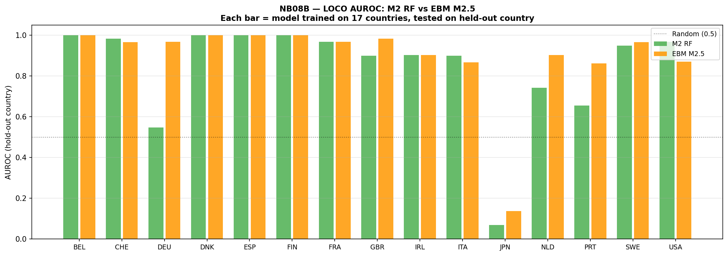
Figure 4.3. Leave-one-country-out AUROC: M2 RF (green) vs EBM M2.5 (orange) for each held-out country, Stage 1 (1988–2020). Each bar represents a model trained on 17 countries, evaluated on the held-out country. Dotted line = random classifier (0.5). AUROC = 1.000 entries reflect trivial single-event ranking.

Table 4.5. Leave-one-country-out summary — M2 RF vs M2.5 EBM, Stage 1
Country | Hold-out events | RF AUROC | EBM AUROC
BEL | 1 | 1.000 | 1.000
CHE | 2 | 0.983 | 0.967
DEU | 1 | 0.548 | 0.968
DNK | 1 | 1.000 | 1.000
ESP | 1 | 1.000 | 1.000
FIN | 1 | 1.000 | 1.000
FRA | 1 | 0.968 | 0.968
GBR | 2 | 0.900 | 0.983
IRL | 1 | 0.903 | 0.903
ITA | 2 | 0.900 | 0.867
JPN | 1 | 0.069 | 0.138
NLD | 1 | 0.742 | 0.903
PRT | 1 | 0.655 | 0.862
SWE | 2 | 0.950 | 0.967
USA | 1 | 0.968 | 0.871
Mean (std) |  | 0.839 (0.254) | 0.893 (0.215)
Table 4.5. AUROC = 1.000 entries reflect trivial single-event ranking. Japan (both models near-random) confirms that asset-deflation dynamics are absent from the training distribution. Mean figures are inflated by single-event results; the cross-sectional pattern reflects sample-specific fitting behaviour rather than stable cross-country generalisation.

EBM shows a higher mean AUROC (0.893 versus 0.839) and lower standard deviation (0.215 versus 0.254) across countries, suggesting more consistent cross-sectional ranking within this evaluation. Country-level differences should be interpreted cautiously.

4.6 SHAP Feature Attribution

4.6.1 Aggregate Attribution by Lag Group
Figure 4.4 presents SHAP attribution for M3 in Stage 2 decomposed by lag group. The total macro share is 73.8 per cent and the FinBERT sentiment share is 26.2 per cent.

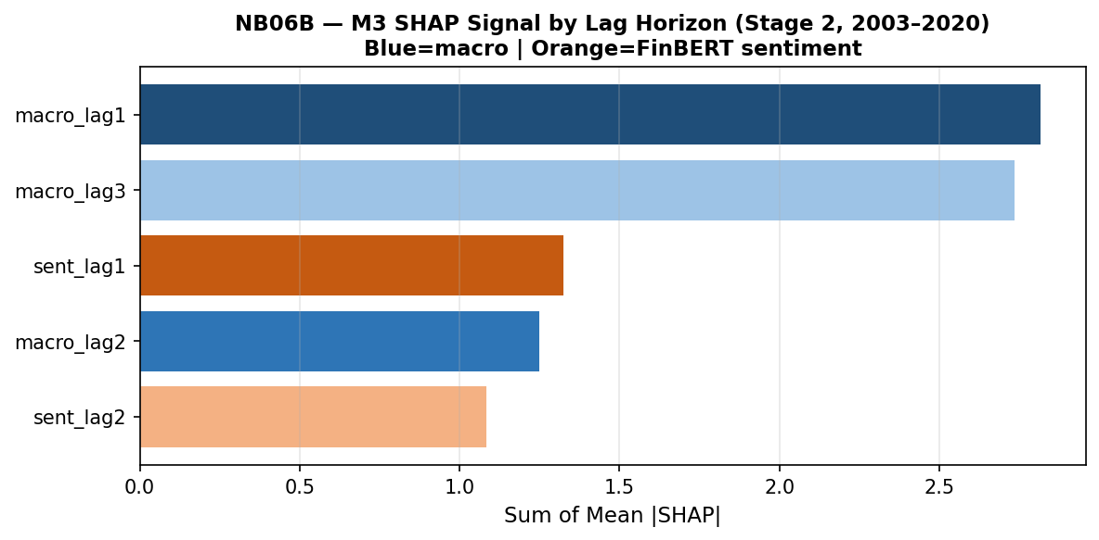
Figure 4.4. M3 SHAP signal by lag horizon (Stage 2, 2003–2020). Dark blue = macro lag1 (2.816); light blue = macro lag3 (2.735); medium blue = macro lag2 (1.249); orange tones = FinBERT sentiment lag1 (1.325) and lag2 (1.083). Macro features account for 73.8% of total attribution; sentiment 26.2%.

The increase from 14.1 per cent sentiment share in the original analysis to 26.2 per cent reflects model re-weighting under a different sample configuration, not evidence of increased economic importance of sentiment. Within the macro group, lag-one features carry the highest aggregate attribution (2.816), marginally ahead of lag-three (2.735) and substantially ahead of lag-two (1.249). SHAP attribution from a single GFC episode cannot be treated as stable or generalisable.

4.6.2 Individual Feature Rankings
The top-20 SHAP feature ranking places the three-year lagged term spread (term_spread_lag3_dm) first by a substantial margin, consistent with the original analysis. The one-year lagged term spread ranks second and the four-year slope of credit growth (tloans_slope4_lag1_dm) ranks third. Five sentiment features appear in the top 20, reflecting the GFC-concentrated evaluation sample.
H2 — Feature relevance: Not supported in its strict formulation. No sentiment feature ranks in the top five. Weakly and conditionally observed in a broader sense: five sentiment features appear in the top 20 and sentiment accounts for 26.2 per cent of aggregate SHAP attribution. Rankings are unstable across specifications and all statistical tests in Section 4.9 are non-significant.

4.6.3 Convergence with EBM Native Importance
Figure 4.5 presents SHAP feature rankings for M3 alongside EBM native feature importance for M2.5, derived without post-hoc attribution.

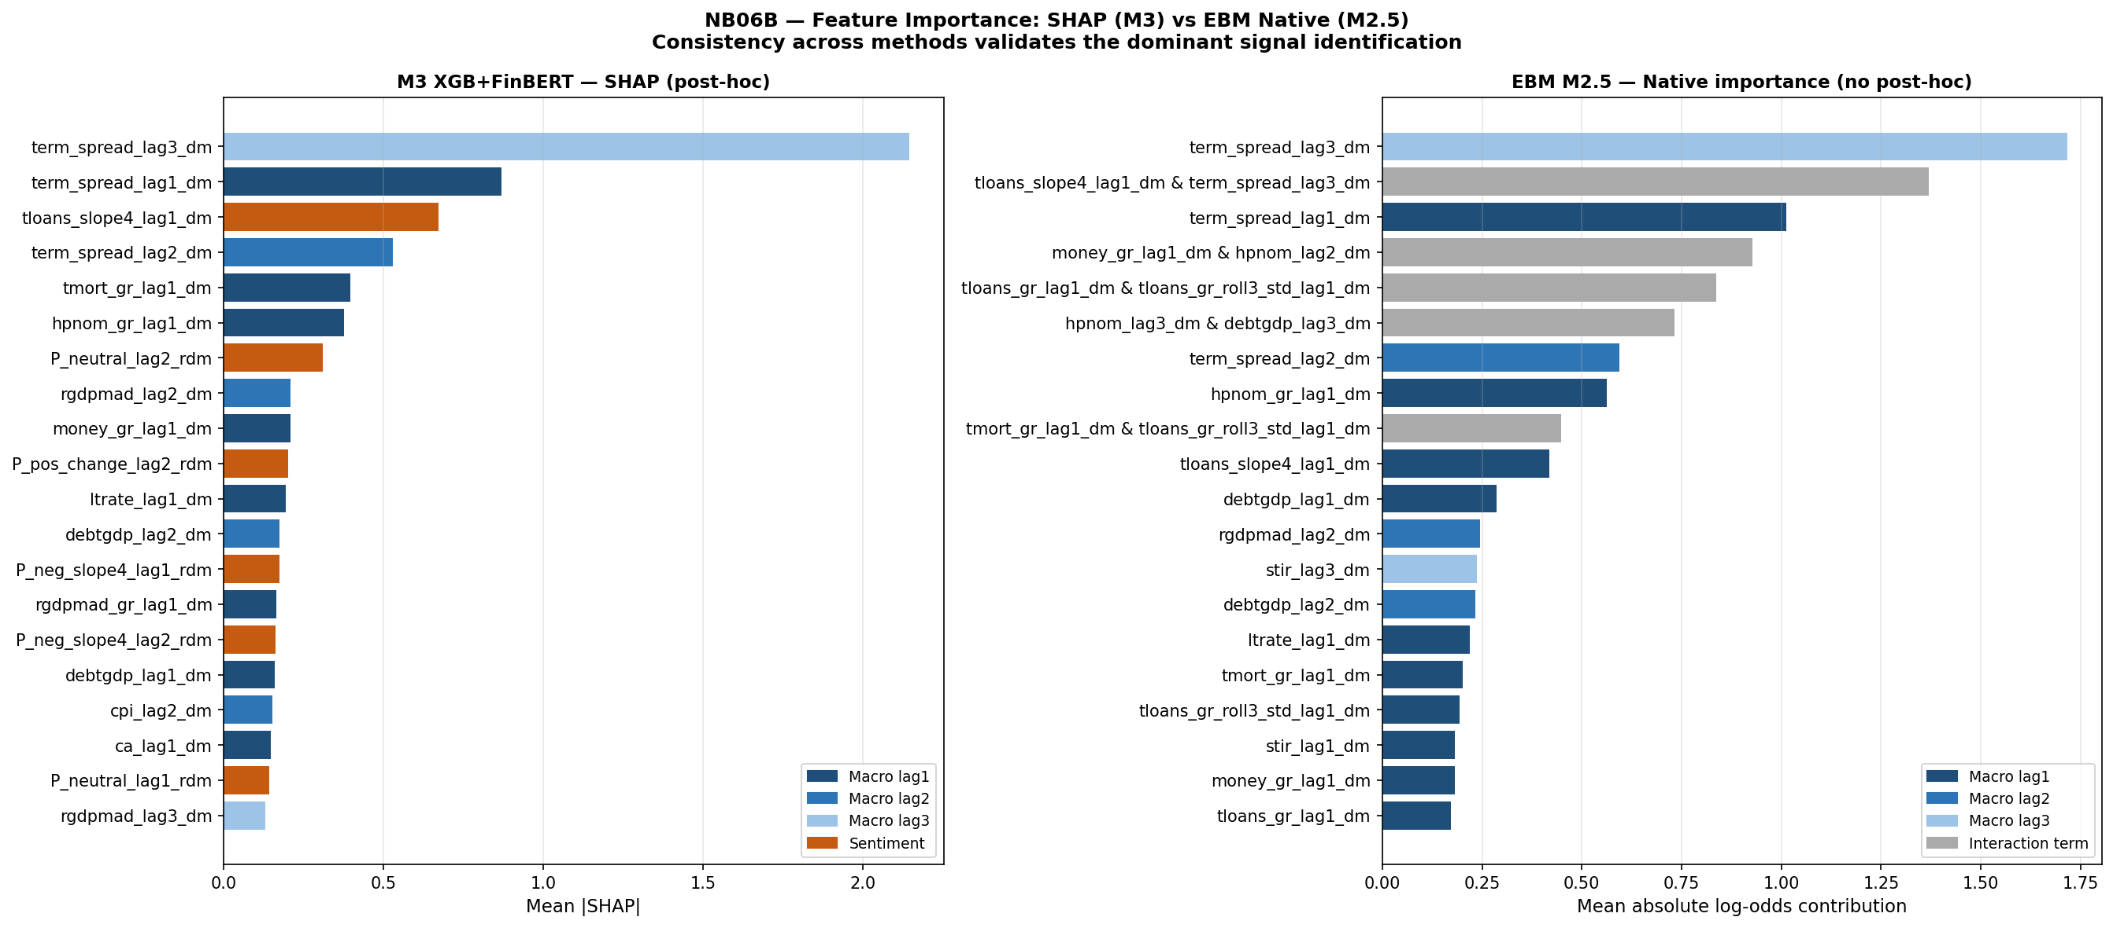
Figure 4.5. Feature importance comparison: M3 SHAP (left, post-hoc) vs EBM M2.5 native importance (right, no post-hoc). Dark blue = lag1; medium blue = lag2; light blue = lag3; orange = sentiment (SHAP only); grey = interaction term (EBM only). Both methods independently identify term_spread_lag3_dm as the dominant feature.

Both methods independently identify term_spread_lag3_dm as the top feature — SHAP assigns it a mean |SHAP| of approximately 2.2, EBM assigns native importance 1.717. This agreement constitutes methodological triangulation: the finding is not an artefact of either the model class or the attribution tool. However, agreement between methods reflects shared sample-specific correlation structure within the GFC episode rather than causal invariance across regimes. EBM additionally surfaces pairwise interaction terms: the interaction between credit growth trajectory and the three-year lagged term spread ranks second by EBM importance (1.370), making explicit a joint signal that M2 and M3 capture implicitly through their decision structures.

4.7 EBM Interpretability Benchmark

4.7.1 Motivation and Design
M2.5 (EBM) is introduced between M2 and M3 in the model sequence to address a specific limitation: both M2 and M3’s feature-risk relationships are accessible only through post-hoc attribution tools such as SHAP, which are approximate, non-causal, and unstable under sample variation (Lundberg and Lee, 2017; Hooker and Mentch, 2019). EBM fits shape functions that are the model itself — no post-hoc approximation is introduced between the fitted parameters and the interpretability output. This property is essential for the test conducted in Section 4.7.3: if shape function instability is observed in EBM, it cannot be attributed to approximation error in a post-hoc tool. It reflects a property of the fitted model rather than an artefact of attribution, and provides evidence of instability in the underlying data-generating process.

4.7.2 Feature Importance

Figure 4.6 presents EBM’s global feature importance for the Stage 2 full-data fit.

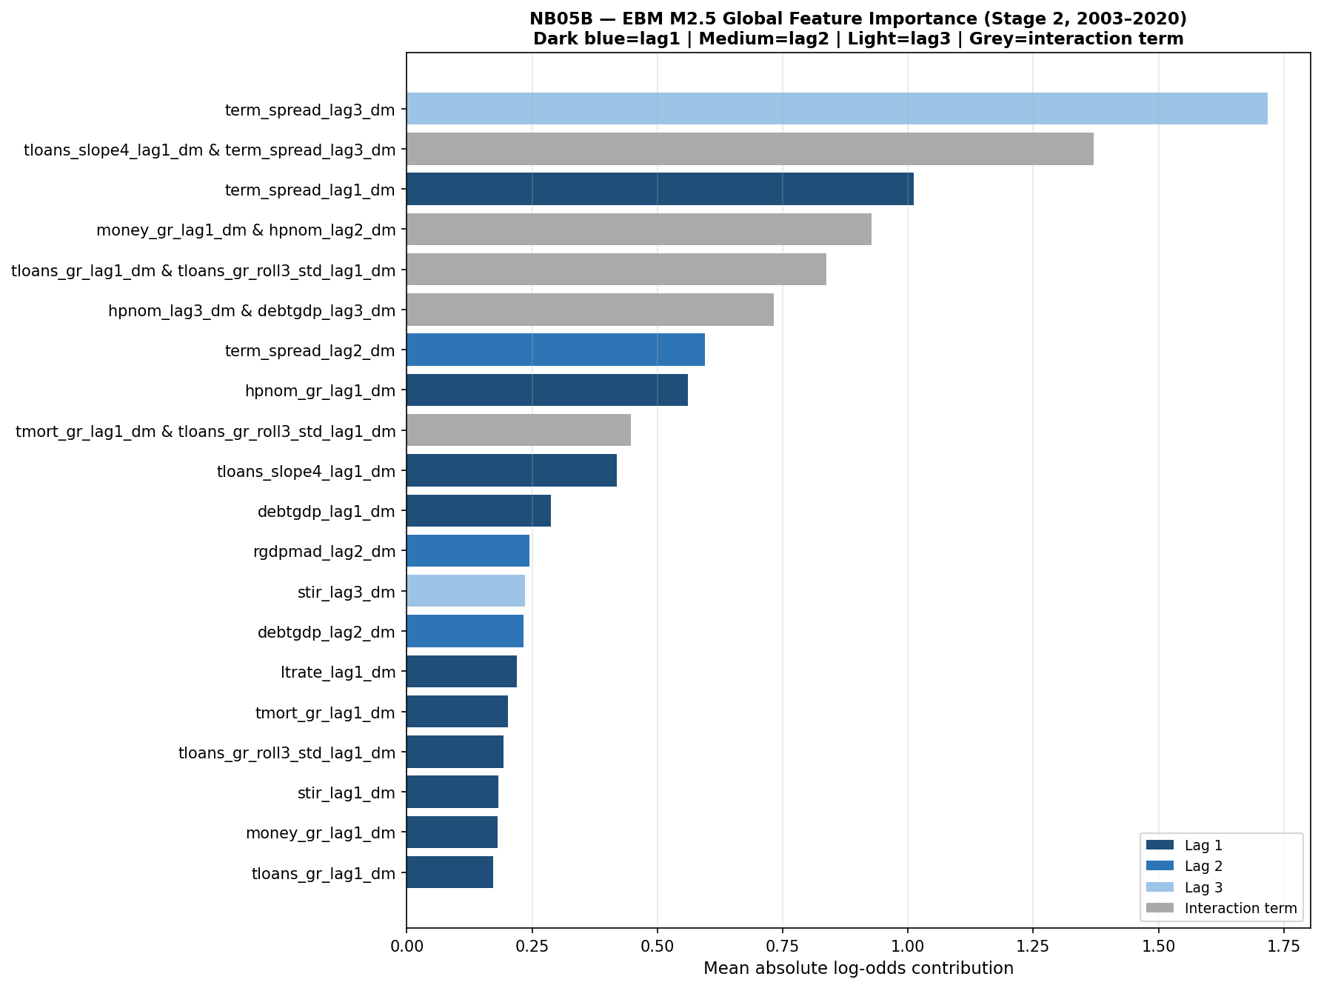
Figure 4.6. EBM M2.5 global feature importance (Stage 2, 2003–2020). Dark blue = lag1; medium blue = lag2; light blue = lag3; grey = interaction term. Term spread at lag 3 (importance 1.717) leads substantially. Term spread appears at all three lag horizons in the top seven features. Signal is concentrated in a small number of economically coherent macro predictors; no sentiment feature appears in the top 20.

EBM’s top five main-effect features are entirely composed of term spread and housing price variables, with term spread at lag three (importance 1.717) leading by a margin of 0.706 over lag one (1.012). The interaction between credit growth trajectory and the three-year lagged term spread ranks second overall (1.370). XGBoost median importance pruning of M3 reduced the feature set from 61 to 31 variables, with removed features concentrated in lower-ranked sentiment and macro-lag-two variables; held-out evaluation was not feasible given insufficient crisis events in the 2016–2020 test window.

4.7.3 Shape Function Analysis: Regime Instability
Figure 4.7 presents EBM shape functions for term spread and total credit across all three lag horizons, estimated separately on a pre-GFC window (2003–2006) and a GFC-inclusive window (2003–2010). This is the centrepiece analysis of the EBM contribution.

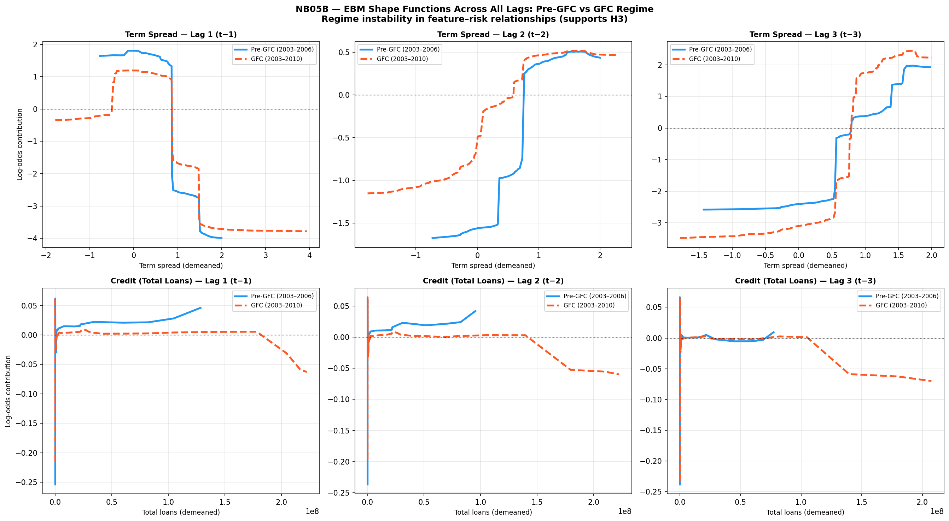
Figure 4.7. EBM shape functions across all lags: Pre-GFC (blue solid, 2003–2006) vs GFC-inclusive (red dashed, 2003–2010). Top row: term spread at lags 1, 2 and 3. Bottom row: total credit at lags 1, 2 and 3. Y-axis: log-odds contribution to crisis probability. Divergence between curves indicates regime-dependent instability in the learned feature-risk mapping.

The lag-3 term spread panel (top right) shows qualitatively distinct shapes — not merely scaled versions — confirming structural instability in EBM’s highest-ranked feature.
The instability of EBM shape functions implies that the mapping from macro-financial indicators to crisis risk is not invariant across time, violating the core assumption underlying early-warning systems. Because EBM requires no post-hoc attribution, this instability is a direct property of the fitted model — it cannot be attributed to approximation error in a SHAP calculation or similar tool.
At lag one, both models produce broadly similar inverted-U patterns but with different magnitudes and transition points. At lag two divergence increases further. At lag three — the highest-ranked EBM feature (importance 1.717) — the instability is most pronounced: the pre-GFC model learns a monotonically increasing risk relationship at positive spread values, while the GFC-inclusive model partially inverts this, with the two curves crossing. The same feature value is associated with reduced risk in one regime and increased risk in the other. For total credit, the pattern is consistent across all three lags: near-zero pre-GFC contributions against increasingly negative GFC-inclusive contributions at high credit values.
These shape plots make visible the mechanism behind the prospective AUROC collapse in Section 4.5: EBM trained on pre-GFC data learns the blue-line relationships; when evaluated on GFC observations, it applies those pre-GFC mappings to a structurally different environment, producing systematic errors that drive AUROC below random. The shape function analysis converts what would otherwise be an opaque model failure into a legible, regime-specific misspecification — which is precisely the contribution that native interpretability makes possible.

An extension of the shape function analysis — applying the same regime comparison methodology to topic-disaggregated central bank sentiment features — is presented in Appendix A. The topic-sentiment extension confirms that structural non-stationarity affects textual features as well as macro-financial indicators, with EBM shape functions for monetary policy and corporate sentiment exhibiting amplitude compression and inflection point shifts between the full-sample and GFC-period models (see Appendix A, Section A.5).

4.8 Calibration Analysis
Figure 4.8 presents the calibration reliability diagrams for all three Stage 2 models.

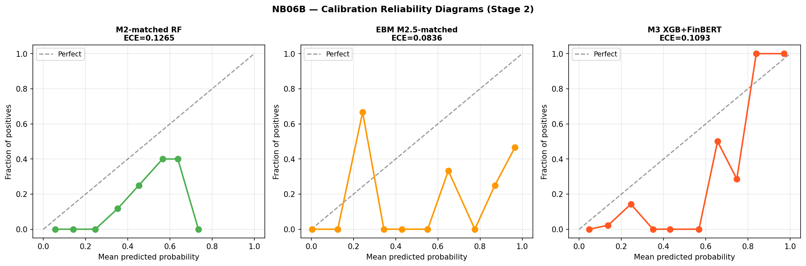
Figure 4.8. Calibration reliability diagrams for Stage 2 models. Left: M2-matched RF (ECE = 0.127). Centre: EBM M2.5-matched (ECE = 0.084). Right: M3 XGB+FinBERT (ECE = 0.109). Dashed diagonal = perfect calibration. Points represent probability bin midpoints vs observed crisis fraction. The noisy appearance reflects 26 crisis events rather than systematic model failure.

Expected Calibration Error for Stage 2 models is 0.127 (M2-matched), 0.084 (M2.5-matched), and 0.109 (M3). EBM appears to achieve the lowest ECE without post-hoc isotonic calibration, in contrast to M3 which applies CalibratedClassifierCV within each fold. Brier Scores are 0.060 (M2-matched), 0.067 (M2.5-matched), and 0.061 (M3). The divergence between EBM’s best ECE and its higher Brier Score reflects the distinction between local calibration and global probability accuracy: ECE rewards smooth probability distributions that align with the empirical crisis rate at the bin level, while Brier Score measures overall squared probability error, which M3’s isotonic calibration directly minimises. EBM produces better-aligned bin-level distributions (lower ECE) without the global squared-error optimisation that isotonic calibration provides (higher Brier). Given 26 crisis events and a single-episode evaluation, neither result is informative about prospective calibration reliability.

4.9 Auxiliary Statistical Tests

4.9.1 Granger Causality: Credit Growth
Granger causality tests for credit growth on the extended Stage 1 panel (1988–2020) find 8 of 42 country-lag combinations significant at 5 per cent — approximately 19 per cent of tests, modestly above the 5 per cent null rate. Belgium shows significance at all three lags; France and the United States at lags two and three; Spain at lag one. Four countries with constant crisis indicators were excluded. These results are directionally consistent with credit-boom dynamics preceding crisis in a minority of countries but do not constitute evidence of a universal or structurally stable predictive channel.

4.9.2 Granger Causality: Term Spread
Granger causality analysis for term spread across 14 countries finds 8 of 42 country-lag combinations significant at 5 per cent overall. At lag three specifically — the EBM dominant lag — 5 of 14 countries are significant: the United Kingdom (p = 0.0016), the Netherlands (p = 0.0028), Italy (p = 0.0092), Japan (p = 0.0151), and Germany (p = 0.0305). EBM’s native importance ranking and country-level Granger F-tests are independent analytical frameworks; both identify the three-year lagged term spread as carrying a distinctive signal. This convergence does not establish causality, and the shape function instability in Section 4.7 demonstrates directly that this statistical relationship is not invariant across regimes.

4.9.3 Panel Logistic: Term Spread
Panel logistic estimation using term spread at all three lag horizons produces a pseudo-R² of 0.135 and a statistically significant likelihood ratio (p < 0.001). The estimated coefficients exhibit a sign reversal across lags: term_spread_lag1_dm carries a negative and significant coefficient (β = −0.646, p = 0.004), while term_spread_lag3_dm carries a positive and significant coefficient (β = +0.630, p = 0.003). This non-monotonic lag structure provides parametric confirmation of the non-linearity identified by EBM’s shape functions: the relationship between term spread and crisis probability changes sign across the lag horizon, and any model that treats this relationship as monotonic is misspecified.

4.9.4 Panel Logistic: Sentiment
Panel logistic on Stage 2 data produces a pseudo-R² of 0.119 for the macro-only specification and 0.153 with sentiment, an increment of 0.034. The P_neg_lag1 coefficient is negative (−6.908) and not significant (p = 0.103). The pseudo-R² increment is treated as directional evidence only.
A topic-disaggregated extension of the sentiment analysis is presented in Appendix A, implementing keyword-filtered FinBERT inference for credit, monetary policy, and corporate topic domains. The topic-sentiment extension finds zero incremental AUROC and AUPRC for EBM relative to the macro-only baseline (Appendix A, Table A.2), confirming that the null result observed here is robust to topic disaggregation.

4.9.5 ML Discrimination vs Statistical Tests
The divergence between ML-based discrimination and the consistent absence of statistical significance is itself the key finding of this section. ML models identify directional AUPRC patterns; Granger tests, panel logistic, and attribution methods find no stable underlying relationship. This highlights the distinction between in-sample predictive pattern recognition and causal economic inference, and explains why high expanding-window metrics coexist with prospective failure.

4.10 EBM Ensemble Extension

4.10.1 Design and Primary Results
Following Holopainen and Sarlin (2017), an EBM-based ensemble is constructed as E1-EBM = 0.5 · P(M2-matched) + 0.5 · P(M2.5-matched) using equal weights throughout. Figure 4.9 presents the ROC and PR curves for all ensemble variants.

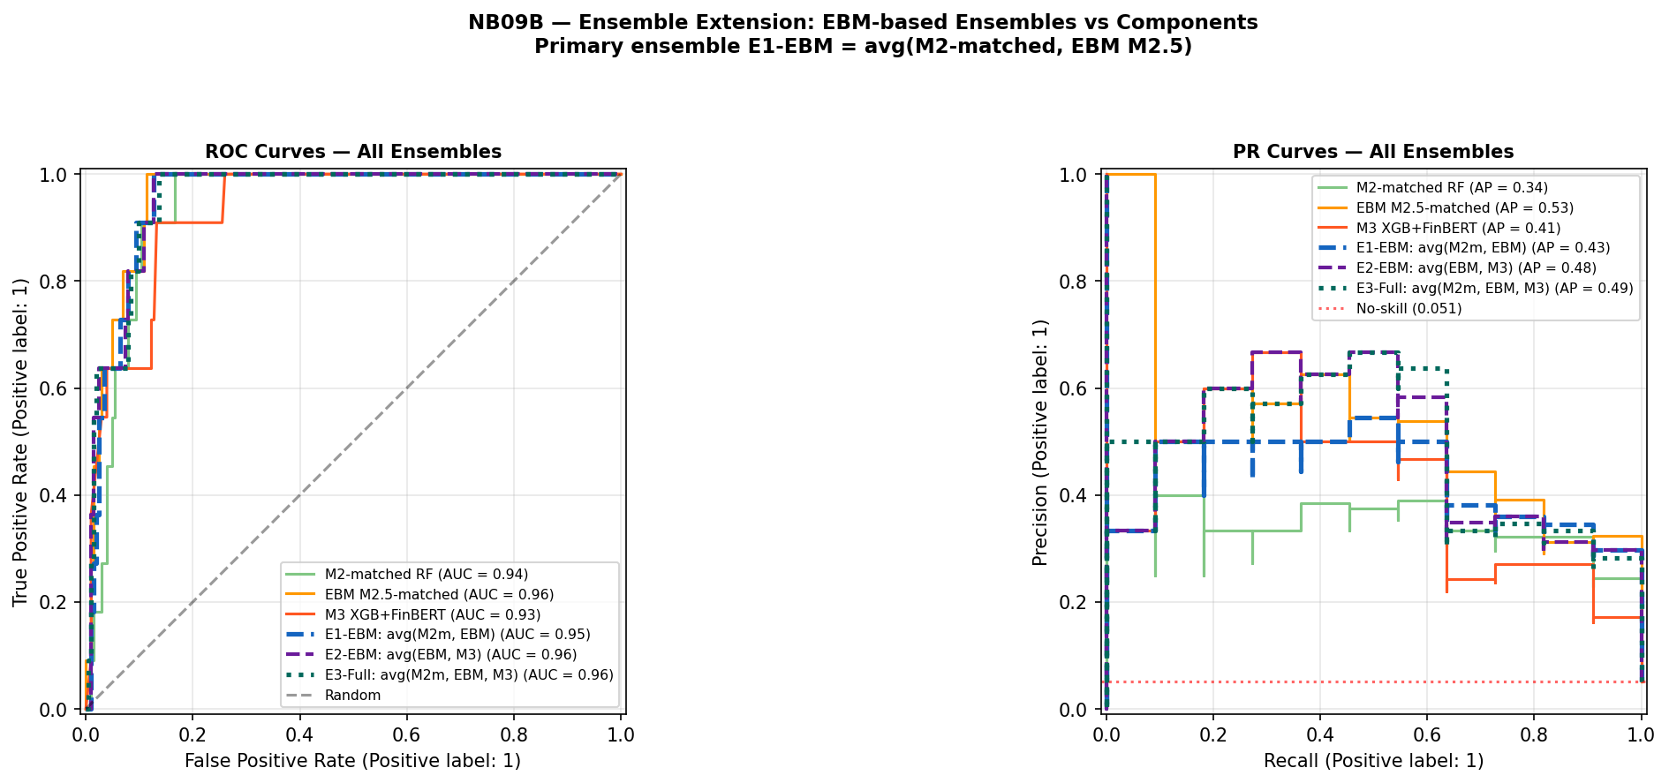
Figure 4.9. Ensemble extension ROC and PR curves (Stage 2 inner-merged OOS, 11 crisis events, base rate 5.1%). Green solid = M2-matched RF; orange solid = EBM M2.5-matched; red solid = M3 XGB+FinBERT; blue dashed = E1-EBM avg(M2m, EBM); purple dashed = E2-EBM avg(EBM, M3); teal dotted = E3-Full avg(M2m, EBM, M3). Red dotted = no-skill baseline. PR curves show that EBM alone (orange) leads on AUPRC; ensemble averaging with lower-AUPRC components reduces the combined AUPRC below EBM’s individual level.

Table 4.6 presents the primary comparison. Metrics are computed on the inner-merged OOS sample (215 observations, 11 crisis events, base rate 5.12 per cent); absolute AUPRC levels are not directly comparable to Tables 4.1–4.2 due to the different evaluation sample. Because the ensemble requires complete overlapping OOS predictions from all constituent models, Table 4.6 is computed exclusively on the inner-merged sample and should not be compared mechanically with Table 4.2; any numerically similar component values reflect coincidence of rank ordering across the two evaluation windows rather than direct reproduction.

Table 4.6. EBM ensemble results — Stage 2 (inner-merged OOS, 11 crisis events)
Model | AUROC | 95% CI | AUPRC | Brier
M2-matched RF | 0.939 | [0.894, 0.971] | 0.343 | 0.060
M2.5-matched EBM | 0.960 | [0.924, 0.986] | 0.532 | 0.067
M3 XGB+FinBERT | 0.932 | [0.869, 0.979] | 0.411 | 0.061
E1-EBM: avg(M2-matched, EBM) | 0.955 | [0.918, 0.982] | 0.433 | 0.056
E1-Orig: avg(M2m, M3) [M4 ref] | 0.943 | [0.895, 0.979] | 0.440 | 0.057
Table 4.6. E1-Orig corresponds to M4 in Table 4.2. Subject to the evaluation constraints of Section 4.1. E1-EBM improves AUROC (+0.012) and Brier (−0.001) over M4 but is marginally lower on AUPRC (−0.007), reflecting the structural drag of averaging EBM (AUPRC 0.532) with M2-matched (AUPRC 0.343).

E1-EBM achieves AUROC 0.955 and Brier Score 0.056 — the lowest Brier Score of any Stage 2 configuration — but AUPRC falls to 0.433 from EBM’s standalone 0.532, as averaging with M2-matched (AUPRC 0.343) pulls precision-recall performance below EBM’s individual level.

4.10.2 Disagreement Analysis
Figure 4.10 presents the model disagreement analysis for all three model pairs.

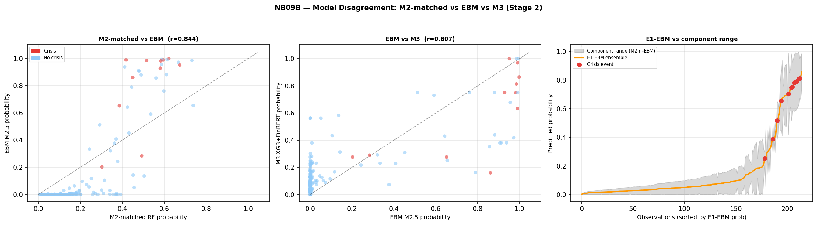
Figure 4.10. Model disagreement analysis (Stage 2). Left: M2-matched RF vs EBM M2.5 probabilities (Pearson r = 0.844); crisis observations in red. Centre: EBM M2.5 vs M3 XGB+FinBERT (r = 0.807). Right: E1-EBM ensemble probability vs M2-matched/EBM component range (grey shading); red dots = crisis events sorted by E1-EBM probability.

Crisis observations show substantially higher disagreement than non-crisis observations across all pairs, consistent with the Holopainen and Sarlin (2017) motivation.
Mean absolute disagreement between M2-matched and EBM is 0.348 at crisis versus 0.125 at non-crisis observations (ratio 2.8:1), consistent with the Holopainen and Sarlin (2017) motivation that ensemble averaging is most valuable precisely where individual model uncertainty is highest. Pearson correlation 0.844 indicates shared signal alongside meaningful complementarity.

4.10.3 2007 Cross-Sectional Ranking
The crisis type analysis presented in this section is explicitly exploratory and post-hoc. Crisis type classifications (Fundamental, Contagion, No crisis) are applied after model training and country ranking; the hypothesis that macro precursor models discriminate by crisis mechanism was not pre-specified as a formal test in the study design. The findings below are therefore presented as descriptive evidence and hypothesis generation — characterising model behaviour within a known episode — rather than as validated model capabilities or confirmed predictions.
Figure 4.11 presents the E1-EBM 2007 country ranking by crisis type.

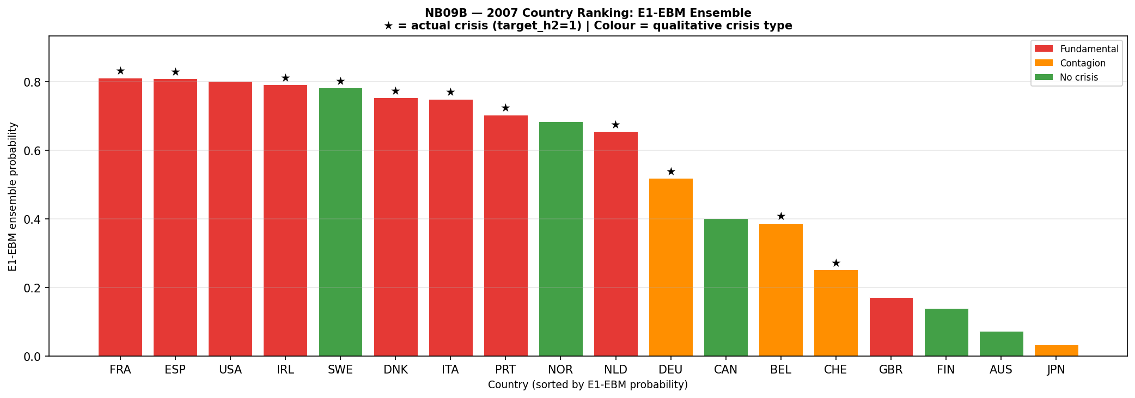
Figure 4.11. 2007 country probability ranking under E1-EBM ensemble, sorted descending. Red = Fundamental crisis; orange = Contagion; green = No crisis. Stars (★) indicate target_h2 = 1 (crisis onset within two years of 2007). Mean E1-EBM by type: Fundamental 0.695 (n=9), Contagion 0.395 (n=5), No crisis 0.325 (n=4). Sweden reclassified as Contagion following JST Macrohistory Database R6 confirmation of banking crisis onset 2008 (target_h2 = 1 in 2007); crisis mechanism was international contagion rather than domestic credit accumulation. The ordering Fundamental > Contagion > No crisis reflects the model’s training on domestic macro credit-cycle precursors.

Countries experiencing fundamental credit-boom crises receive a mean E1-EBM probability of 0.695 (n = 9), compared with 0.395 for contagion-driven cases (n = 5) and 0.325 for countries with no systemic event (n = 4). The model’s 2007 country ranking is consistent with mechanism-specific differentiation: macro precursor-based models assign higher probabilities to crises driven by domestic credit dynamics than to those transmitted through cross-border contagion channels. Two country-level results warrant qualification. Sweden (E1-EBM 0.783, rank 5, Contagion ★) is a true positive: JST Macrohistory Database R6 records banking crisis onset in 2008, with target_h2 = 1 in 2007; the crisis mechanism was international contagion rather than domestic credit accumulation, which explains the model’s high probability despite limited domestic imbalance in the 2004–2006 feature window.
The United Kingdom (E1-EBM 0.171, rank 15, Fundamental) records target_h2 = 0 in 2007 under JST’s chronology, placing it outside the statistical crisis window; qualitatively, its 2007–2008 stress is well-documented but the model does not flag it, a scope condition examined in Chapter 5.
The United States (E1-EBM 0.802, rank 3, Fundamental) records target_h2 = 0 in 2007 under the same chronology, making it a statistical false positive despite its role as the epicentre of the GFC; the model’s high probability reflects correct identification of domestic credit-boom precursors, but the JST onset date falls outside the two-year prediction horizon.
Subject to the evaluation constraints of Section 4.1, this cross-sectional pattern characterises model behaviour within the GFC episode and reflects the scope conditions of the macro precursor approach rather than a generalisable discrimination capability by crisis type.

4.11 Hypothesis Assessment
Table 4.7. Hypothesis assessment under the augmented two-stage pipeline with EBM extension

Hypothesis | Stated prediction | Key evidence | Verdict
H1: Discrimination | M3 achieves higher AUROC/AUPRC than macro-only benchmark | Stage 2 Cross-Sectional Case Study (2007 GFC): M3 AUPRC 0.411 > M2-matched 0.343 (directional). Primary comparison: M2.5 EBM macro-only (AUPRC 0.532) versus M3 macro plus sentiment (AUPRC 0.411) — EBM outperforms M3 without any sentiment features, isolating algorithm non-linearity as the dominant factor. The M2-matched vs M3 comparison confounds algorithm and feature changes simultaneously. Bootstrap CI [−0.130, +0.312] spans zero. | Supported directionally on AUPRC within the 2007 GFC Cross-Sectional Case Study. The EBM/M3 comparison cannot cleanly isolate the sentiment contribution because model class, regularisation, and features all vary simultaneously; Stage 2 gains are at least as sensitive to algorithm choice as to sentiment augmentation. Not statistically confirmed. All figures are in-crisis discrimination measures, not prospective predictions.
H2: Feature relevance | At least one FinBERT feature ranks top-5 by SHAP | 5 sentiment features in top 20; SHAP share 26.2%. EBM native importance corroborates macro dominance independently. Agreement between methods reflects shared sample-specific correlation structure, not causal evidence. All statistical tests non-significant. | Not supported in strict formulation. Weakly and conditionally observed. Two independent attribution methods converge on macro dominance within the GFC sample.
H3: Interpretability trade-off | Quantifiable accuracy-interpretability trade-off across M1–M2–M3 | M1→M2: AUPRC +0.085 at H2 with loss of log-odds transparency. M2→M2.5: within expanding-window evaluation, interpretable EBM appears to achieve higher point estimates than black-box RF. EBM collapses more severely under prospective validation (AUROC 0.333 vs RF 0.481), demonstrating that interpretability does not confer prospective robustness and may increase vulnerability to regime-specific overfitting. | Supported and refined. Trade-off is not binary within the non-linear model class under expanding-window evaluation. This refinement does not alter the central conclusion: neither interpretability nor algorithm choice resolves the regime instability problem.
Table 4.7. Hypothesis assessment under the augmented two-stage pipeline (NB01A–NB09B). AUPRC at H2 is the primary metric. All Stage 2 verdicts reflect cross-sectional discrimination within the GFC episode only.

The three hypotheses together trace a coherent argument about the structural limits of ML-based crisis prediction. H1 is directionally supported but Stage 2 performance differences reflect algorithm non-linearity at least as much as sentiment signal. H2 fails its strict formulation; SHAP and EBM agreement reflects shared sample correlation structure, not causal validation. H3 is supported but qualified: interpretability does not confer prospective robustness and may increase vulnerability under regime change.
Taken together, these results indicate that the central limitation of early-warning systems is not predictive capacity within a given sample, but the absence of a stable mapping between predictors and crisis outcomes across regimes — a limitation that cannot be resolved through additional data, model complexity, or interpretability enhancements. This implies that early-warning systems are not merely empirically limited, but conceptually misaligned with environments characterised by structural breaks, where the underlying data-generating process evolves faster than any static model can adapt. In this sense, the failure of machine learning-based early-warning systems reflects a broader limitation of predictive modelling under distribution shift, where models trained on historical data cannot reliably extrapolate to future states drawn from a different underlying process.

This indicates that the limitation of early-warning systems lies not in insufficient model capacity, but in the absence of a stable relationship to be learned.

Chapter 5: Discussion

5.1 Overview of Findings
This chapter synthesises the results reported in Chapter 4, situates them within the broader early-warning system (EWS) literature, and draws out the implications for research design, practical application, and the theoretical limits of machine learning-based crisis prediction. Five interlocking findings define the contribution of the augmented analysis, the fifth of which — the EBM interpretability benchmark — is the most theoretically significant addition relative to the original study.

The first finding is negative: extending macro training history from the original 2003–2020 panel to 1989–2020, spanning the Nordic cluster, Japan 1997, and other pre-GFC episodes, does not resolve the EWS generalisation problem. M2 achieves AUROC 0.481 in strict temporal validation — below random — demonstrating that the failure is not an artefact of short training data but of structural regime discontinuity that additional pre-GFC history cannot bridge.

The second finding concerns sentiment augmentation. Within the Stage 2 Cross-Sectional Case Study, M3 achieves AUPRC 0.411 against M2-matched’s 0.343, but the bootstrap 95% CI spans zero, auxiliary statistical tests find no significant sentiment–crisis relationship, and the EBM benchmark (macro-only, AUPRC 0.532) outperforms M3 without any sentiment features. The M3 advantage cannot be attributed to a stable sentiment signal: Stage 2 performance differences are at least as sensitive to model class as to the sentiment feature extension.

The third finding is the EBM interpretability benchmark. M2.5 achieves higher expanding-window point estimates than both M2 and M3, while providing natively interpretable shape functions requiring no post-hoc attribution. The theoretically significant result is EBM’s prospective collapse: AUROC 0.333 in Split B, below M2’s 0.481 and below random. This directly refutes the implicit assumption that interpretable models might be more robust; within the constrained Split B evaluation, EBM’s higher flexibility appears to produce more aggressive regime-specific fitting, not greater generalisability.

The fourth finding is the ensemble extension. E1-EBM achieves AUROC 0.955 and Brier 0.056 — the best global probability accuracy in Stage 2 — while E1-Orig achieves comparable AUPRC (0.440 versus E1-EBM’s 0.433) but slightly higher Brier (0.057). All ensemble results are conditioned on the single-episode GFC evaluation and do not establish prospective reliability.

The fifth finding is the 2007 cross-sectional crisis-type discrimination. E1-EBM assigns mean probability 0.695 to fundamental credit-boom crises (n=9), 0.395 to contagion-driven cases (n=5), and 0.325 to no-crisis countries (n=4) — following Sweden’s reclassification as Contagion per JST R6. This stratification indicates mechanism-specific signal in the macro features, as a post-hoc exploratory result for a single episode.

Together, these five findings point to a single underlying cause: structural instability in the mapping between predictors and crisis outcomes across regimes. Section 5.2 develops the theoretical implications of this conclusion.

5.2 The EBM Interpretability Benchmark: What Native Transparency Reveals

The introduction of M2.5 (EBM) represents the most theoretically significant extension of the original study. Its contribution is not the performance metrics — which are subject to the same evaluation constraints as all other models — but what its shape functions reveal about the structure of the learning problem.

Because EBM’s shape functions are the model itself rather than a post-hoc approximation, any instability observed in them must reflect a property of the data-generating process rather than an artefact of the attribution method. The shape function analysis (Section 4.7.3) confirms this directly: the learned feature-risk mapping is regime-dependent at every lag horizon examined. For term spread at lag three — the highest-ranked EBM feature (native importance 1.717) — the pre-GFC and GFC-inclusive models produce qualitatively distinct shapes rather than scaled versions of each other, with the two curves crossing. The same feature value is associated with reduced crisis risk under one regime-specific representation and increased risk under the other. For credit features, the pre-GFC model assigns near-zero contributions (no crisis events from which to identify an association) while the GFC-inclusive model assigns increasingly negative contributions at high credit values. This instability is not an artefact of SHAP approximation; it is a direct, readable property of what the model has learned. It bears emphasis that the shape function instability documented here is observed within the expanding-window evaluation — a setting that, as Section 4.5 establishes, produces upper-bound metrics rather than true prospective estimates. The instability is real and analytically important, but it is detected within the same evaluation regime that inflates all other metrics. Its value lies in converting model failure into a legible, regime-specific misspecification, not in providing a new metric of prospective performance.
The implications extend beyond specific features. EBM shape function instability confirms that the mapping from macro-financial indicators to crisis risk is not time-invariant, placing crisis prediction within the broader class of non-stationary learning problems. Static, pooled EWS designs are not merely empirically limited — they may be conceptually misaligned with structural break environments. Regime-switching models, mechanism-specific classifiers, or Bayesian updating frameworks could partially address this, but are beyond the present scope.

The convergence between SHAP attribution on M3 and EBM native importance strengthens this conclusion while preventing overinterpretation. Both methods independently identify term_spread_lag3_dm as the dominant signal, and Granger causality tests find this feature significant in 5 of 14 countries at lag three (United Kingdom p = 0.0016, Netherlands p = 0.0028, Italy p = 0.0092, Japan p = 0.0151, Germany p = 0.0305). However, agreement across methods reflects a shared sample-specific correlation structure within the GFC cross-section — not causal invariance across regimes, which the shape function instability directly refutes. The panel logistic sign reversal — lag-one term spread coefficient β = −0.646 (p = 0.004) against lag-three coefficient β = +0.630 (p = 0.003) — provides parametric confirmation that the relationship is non-monotonic and therefore cannot be represented by any model that treats it as linear.

5.3 The Ensemble as a Response to Model Uncertainty

The ensemble extensions operationalise the Holopainen and Sarlin (2017) insight: combining predictions across different architectures is preferable to single-model selection under small-sample, crisis-concentrated evaluation. Equal weighting is used throughout; performance-weighted schemes are circular when weights derive from the same OOS pool used for evaluation.
The disagreement analysis provides the substantive justification. The Pearson correlation between M2-matched and EBM predicted probabilities is 0.844 — substantial shared signal without redundancy. Mean absolute disagreement at crisis observations is 0.348, against 0.125 at non-crisis observations — a ratio of 2.8:1 — meaning the ensemble’s moderating effect is strongest precisely at the highest-stakes observations.
This is the condition Holopainen and Sarlin (2017) identify as the primary motivation for ensemble averaging.
E1-EBM achieves lower AUPRC (0.433) than EBM alone (0.532) — averaging with M2-matched pulls precision-recall below EBM’s individual level — but Brier Score 0.056 is the best of any Stage 2 configuration. For well-calibrated probability estimates for policy thresholds, the ensemble is preferable; for ranking crisis countries within a known episode, EBM alone achieves higher point estimates.

5.4 Crisis Heterogeneity and Model Scope
A structural limitation of all model designs in the EWS literature, including the present analysis, is that crisis target variables derived from banking crisis chronologies are outcome-based rather than mechanism-based. The Laeven and Valencia (2020) chronology records when a systemic banking crisis occurred but makes no distinction between crises driven by domestic credit-boom dynamics, those transmitted through contagion channels, and those triggered by exogenous shocks. Training a model on this undifferentiated label implicitly assumes that the same set of macro and sentiment features is relevant across all crisis types — an assumption that the evidence in this chapter consistently refutes.

Four crisis mechanisms are relevant: (1) fundamental crises driven by domestic credit booms and asset price accumulation (Nordic cluster, Japan 1990s, US/Ireland/Spain pre-GFC) — the type EWS macro features are designed to detect; (2) contagion crises propagated through financial linkages without domestic imbalance (Germany, Belgium, Switzerland 2007–08); (3) speculative attacks against fixed exchange rates (ERM 1992; Obstfeld, 1996); and (4) exogenous real shocks such as COVID-19, appropriately excluded from the crisis chronology. Training on an undifferentiated target that conflates all four introduces noise into the learning problem.
The 2007 cross-sectional ranking under E1-EBM provides qualified, exploratory evidence of mechanism-specific discrimination. This analysis is explicitly post-hoc: crisis type classifications are applied after model training and country ranking, and the hypothesis that macro precursor models would discriminate by crisis mechanism was not pre-specified as a formal test in the study design. The following findings are therefore presented as descriptive evidence and hypothesis generation — characterising model behaviour within a known episode — rather than as validated model capabilities. The mean E1-EBM probability for fundamental crisis countries (0.695, n = 9) substantially exceeds both contagion-driven cases (0.395, n = 5) and the no-crisis group (0.325, n = 4). Group counts reflect the reclassification of Sweden from No crisis to Contagion following confirmation from JST Macrohistory Database R6 that banking crisis onset occurred in 2008 (target_h2 = 1 in 2007). This stratification is coherent with the model’s design: macro features capturing credit conditions, interest rate dynamics, and housing price trends carry more signal for domestically generated imbalances than for externally transmitted stress. The corresponding finding for M4 in the original analysis (fundamental mean 0.599, contagion 0.281) shows the same directional ordering, consistent across both ensemble specifications.

The country-level labels that follow — fundamental crisis, contagion, and no crisis — refer to qualitative mechanism classification and should be distinguished from the binary JST target_h2 evaluation label: Sweden and the United States are statistical positives (target_h2 = 1 in 2007); the United Kingdom is a statistical negative (target_h2 = 0 in 2007). Two country-level results warrant explicit discussion. Sweden (E1-EBM probability 0.783, rank 5) registers as a true positive: the JST Macrohistory Database R6 records banking crisis onset in 2008, with target_h2 = 1 in 2007. Sweden’s elevated credit growth and asset price dynamics in the 2004–2006 period are consistent with precursor conditions for a fundamental crisis, and the model correctly assigns a high probability on that basis. The crisis mechanism, however, was contagion from international markets rather than domestically generated imbalance — an important qualification addressed in Section 5.4.1. The United Kingdom (E1-EBM probability 0.171, rank 15) is the most prominent qualitative scope failure: the JST target_h2 label is 0 in 2007, placing it outside the statistical crisis window. It is therefore not a statistical false negative under the binary evaluation criterion, but a qualitative economic mismatch — the model assigns low risk to a country whose banking stress is economically central to the GFC narrative. The mechanism behind this mismatch is examined in detail in Section 5.4.1. Both cases illustrate the limits of the macro precursor approach and are consistent with the crisis heterogeneity argument developed above.

5.4.1 Feature-Level Evidence: Spain, Sweden, and the United Kingdom
The 2007 cross-sectional ranking provides the basis for a structured feature-level case study across three countries that span the range of model outcomes: Spain (correct hit; E1-EBM 0.810†), Sweden (true positive; E1-EBM 0.783), and the United Kingdom (qualitative scope failure, target_h2 = 0; E1-EBM 0.171). Examining the macro feature values that the model observed for each country in the 2004–2006 period — the lagged window that feeds the 2007 prediction — illustrates both the discriminatory logic of the EBM and the scope conditions under which it fails.

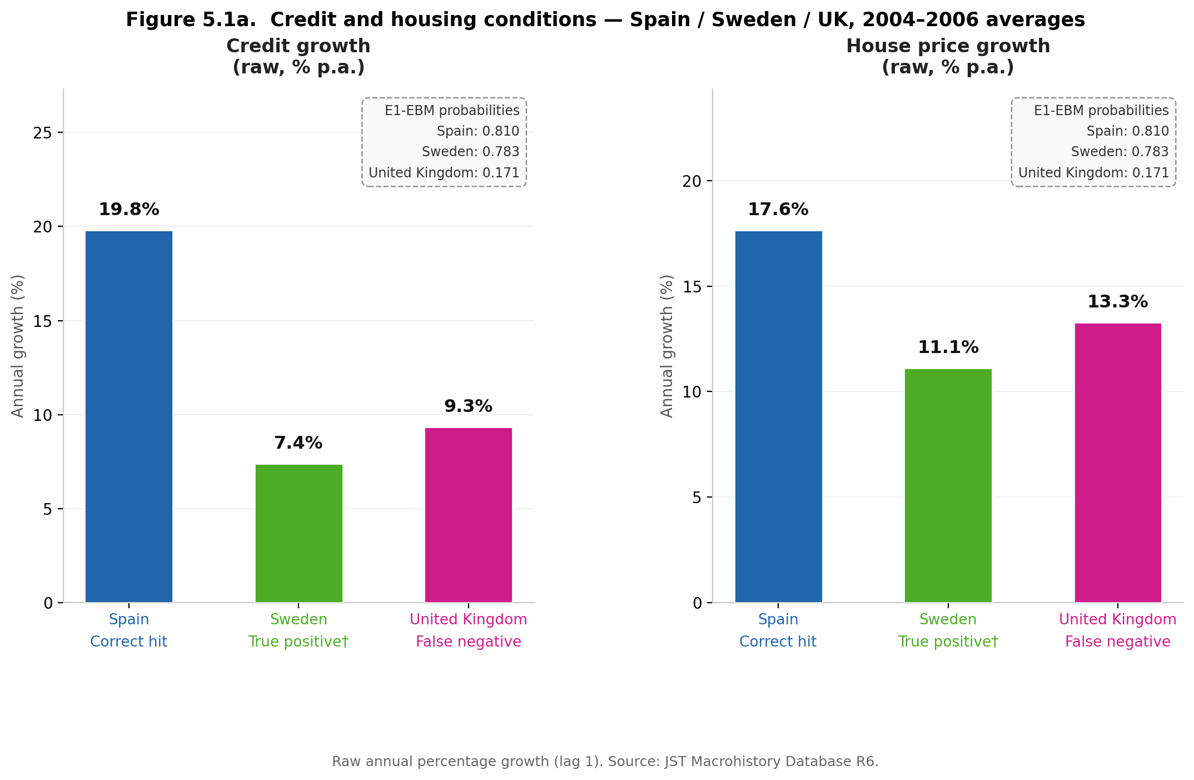

Figure 5.1a presents credit and housing conditions averaged over 2004–2006. Spain’s credit growth (19.8% p.a.) and house price growth (17.6%) are consistent with the classic pre-crisis domestic boom pattern (Schularick and Taylor, 2012); EBM shape functions assign increasing crisis probability at elevated credit growth, and Spain sits well into the high-risk segment. Sweden’s credit growth (7.4%) and house price growth (11.1%) are moderate; the model’s high probability for Sweden (0.783) reflects overlap on yield-curve and monetary accommodation signals, which are not mechanism-specific and do not discriminate domestic boom from contagion exposure.

The United Kingdom is more precisely a scope condition than a model error. UK 2007–08 stress originated on the liability side — short-term wholesale funding of mortgage books — rather than asset-side imbalance accumulation. The model’s inputs (credit growth 9.3%, house price growth 13.3%) correctly receive low crisis probability; the crisis mechanism (funding-channel fragility) lies outside the feature set’s scope. This is not model failure; it is a legitimate scope limit of the macro precursor approach.

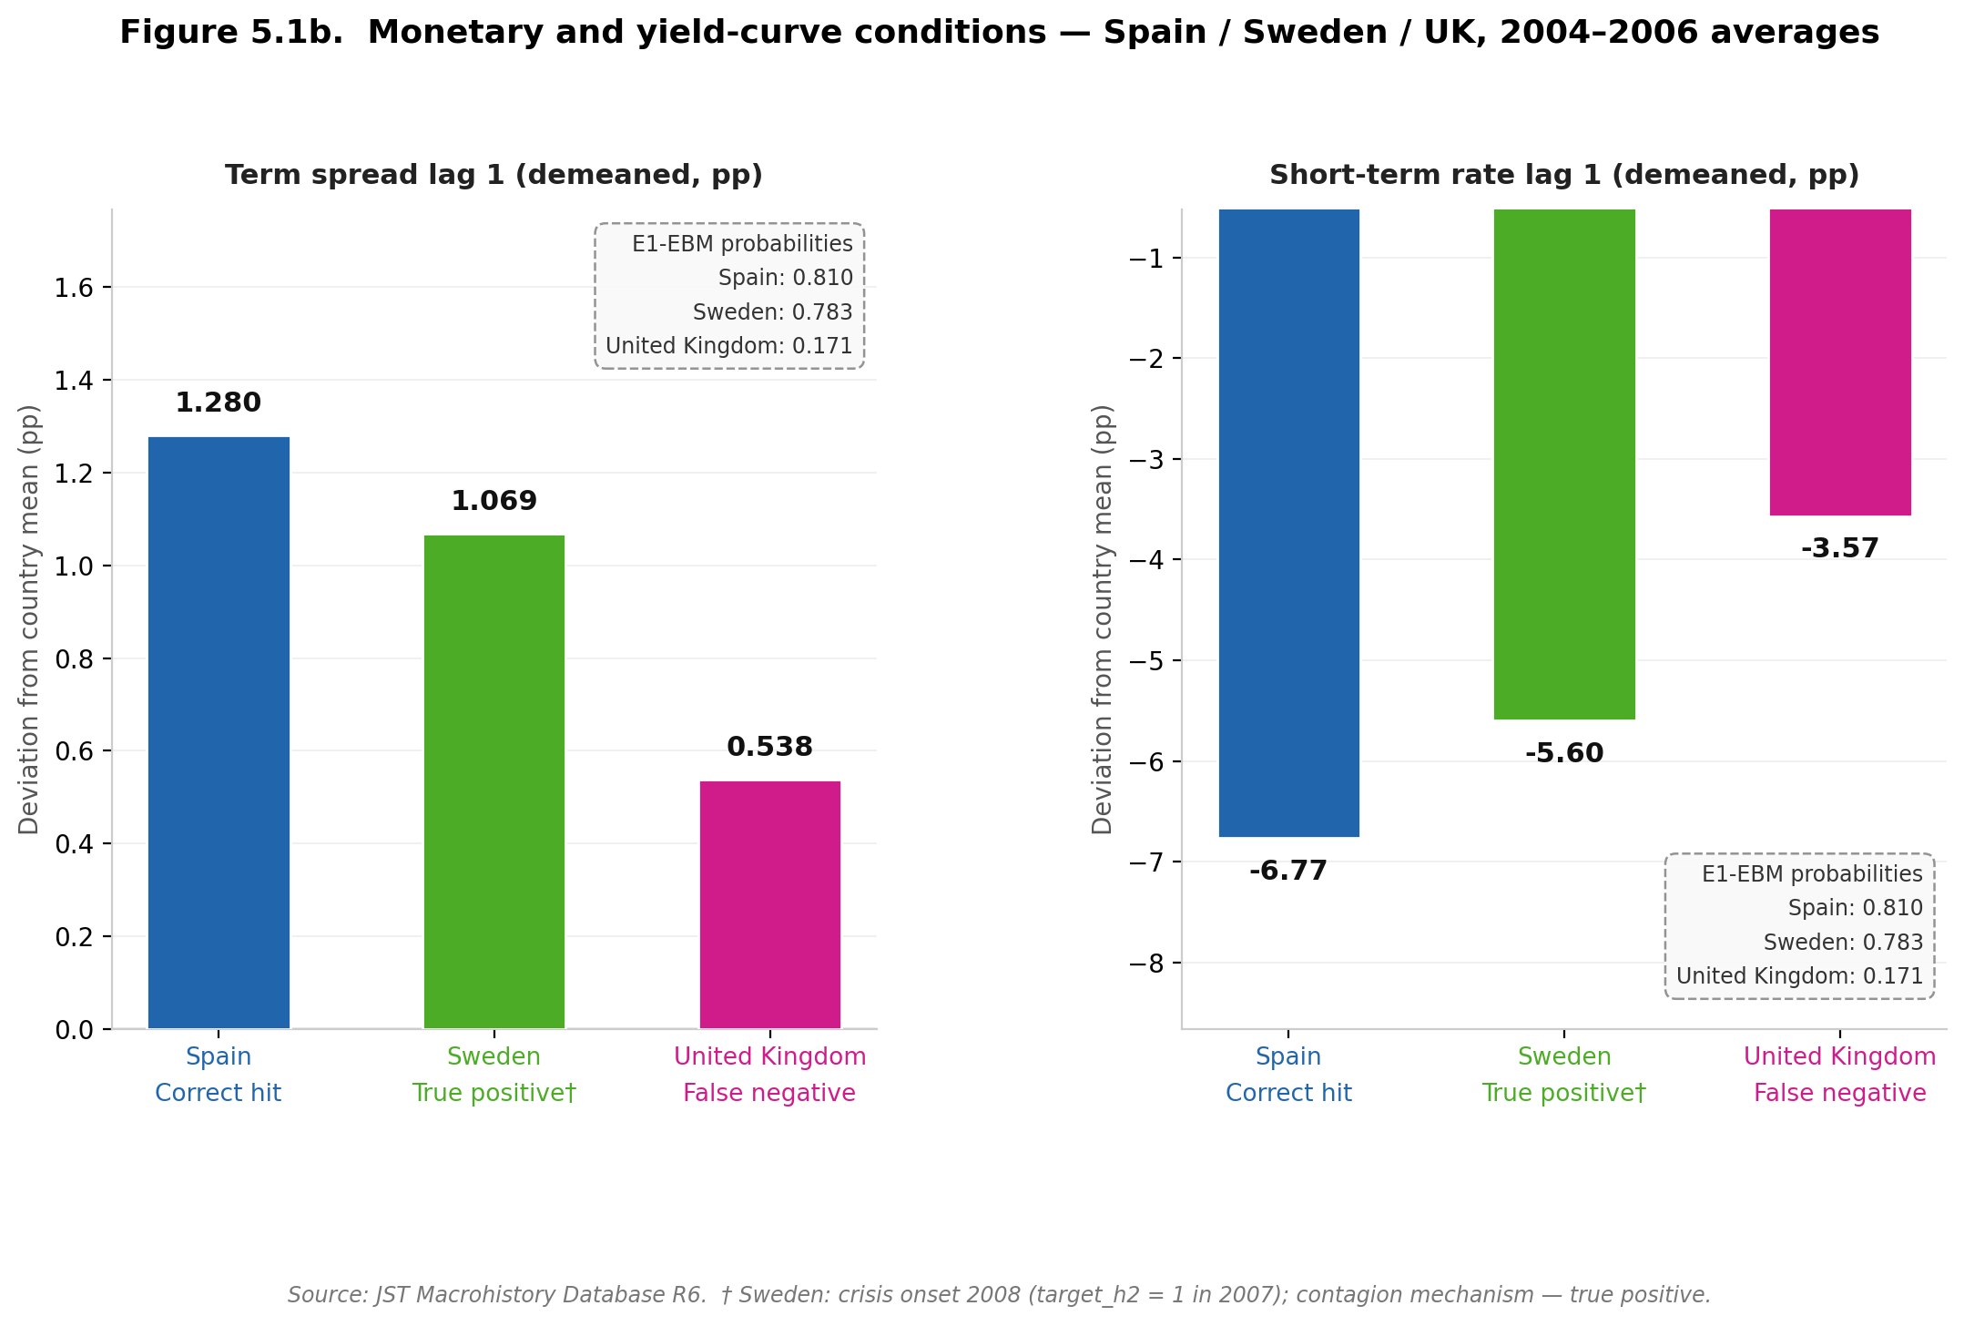

Figure 5.1b presents the monetary and yield-curve conditions, expressed as deviations from each country’s expanding historical mean at lag 1. All three countries display term spreads above their historical averages (Spain 1.280 pp, Sweden 1.069 pp, United Kingdom 0.538 pp) and short-term rates substantially below their historical averages (Spain −6.77 pp, Sweden −5.60 pp, United Kingdom −3.57 pp). The directional pattern is consistent across all three cases: highly accommodative monetary conditions relative to each country’s own history, combined with steepened yield curves, reflect the shared low-rate environment of the mid-2000s rather than country-specific imbalance. This limits the discriminatory power of monetary and yield-curve features at the cross-sectional level: they contribute to elevated aggregate crisis probabilities across the sample but do not differentiate Spain’s domestic credit boom from Sweden’s contagion exposure or the United Kingdom’s funding-channel vulnerability.

The contrast between the two figures makes the model’s logic visible without post-hoc attribution. Spain is distinct in Figure 5.1a — credit and house price growth two to three times Sweden’s and the UK’s — but all three are similar in Figure 5.1b, with shared accommodative monetary conditions providing little cross-sectional discriminatory power. The model’s crisis signal concentrates in credit-cycle dynamics; its errors have identifiable mechanistic causes. That legibility is EBM’s native interpretability contribution.

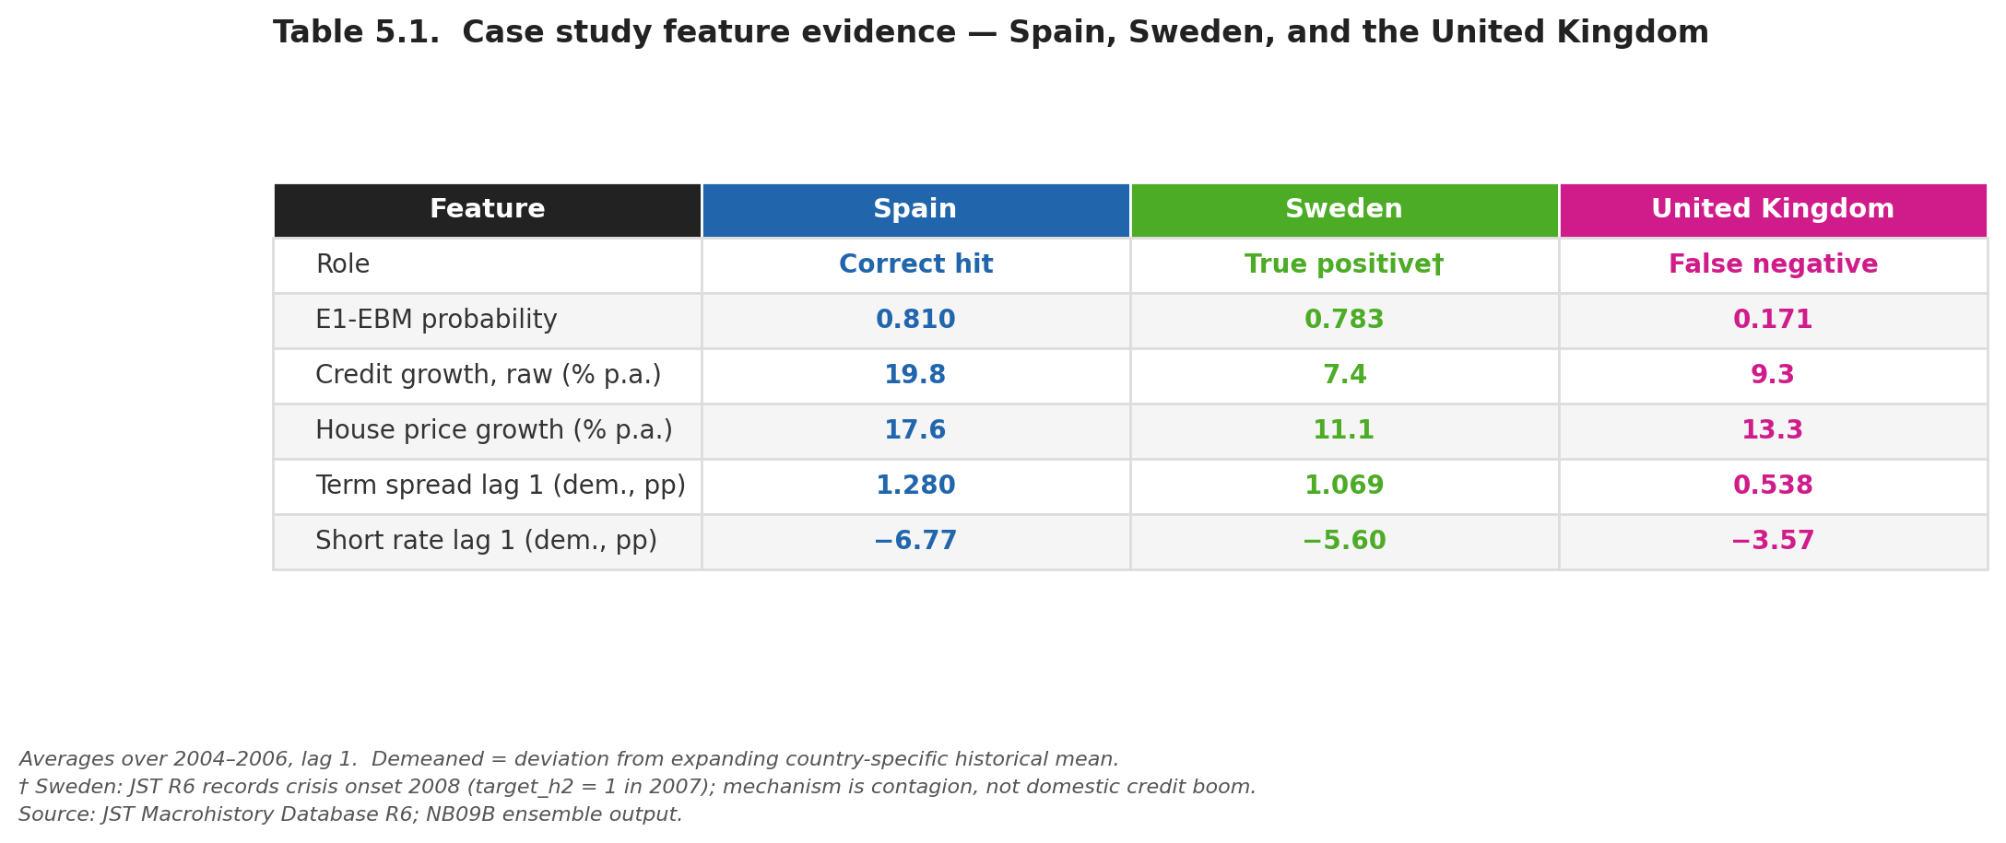

Spain’s E1-EBM probability in the 2007 cross-section is 0.810 (rank 2), taken from the NB09B ensemble output. Sweden’s banking crisis onset is recorded as 2008 in the JST Macrohistory Database R6 (target_h2 = 1 in 2007); the crisis mechanism was contagion from international markets rather than domestic credit accumulation. All feature values are averaged over 2004–2006 at lag 1; demeaned values represent deviations from the expanding country-specific historical mean.

5.5 Implications for Early-Warning System Design

Four practical implications follow from the augmented analysis, stated with appropriate caution given the evaluation constraints throughout Chapter 4.

First, extending training history is necessary but not sufficient. The dominant constraint on EWS performance is regime heterogeneity rather than data length: models trained on one precursor pattern do not generalise to structurally different episodes. An operational EWS would require a regime-classification layer or a portfolio of mechanism-specific models rather than a single general-purpose classifier.

Second, interpretable non-linear models such as EBM offer a capability black-box models cannot provide: direct observation of whether learned feature-risk relationships are regime-stable. The shape function instability in Section 4.7.3 converts opaque model failure into legible, regime-specific misspecification. In a policy context, a regulator who can see that the model’s learned mapping has shifted can apply appropriate scepticism; SHAP on a black-box model provides no equivalent direct signal. However, this recommendation comes with the Split B qualification: greater interpretability via EBM does not confer prospective robustness and may increase sensitivity to regime-specific overfitting.

Third, the ensemble design is most defensible for calibration rather than discrimination reasons. M2-matched and M3 cannot be definitively ranked on AUPRC (CI spans zero). E1-EBM achieves Brier 0.056, better than M2-matched (0.060) and EBM alone (0.067) — a practically important property for systems assigning probability thresholds for policy review, qualified by absence of prospective validation across multiple crisis episodes.

Fourth, central bank sentiment contributes a directional but unstable signal. The SHAP attribution shift across analyses reflects model re-weighting under different sample configurations, not a change in the underlying economic relationship. The panel logistic pseudo-R² increment of 0.034 with a non-significant coefficient (p = 0.103) reinforces caution. An operational sentiment channel would require validation across multiple structurally distinct crisis episodes before deployment.

5.6 Limitations
Several limitations constrain the interpretation of results throughout this analysis.

The single-episode evaluation structure is the dominant constraint. Stage 2 evaluation rests on crisis events in a single year — 2007 — across 18 countries. This is cross-sectional country ranking within a known crisis episode, not temporal predictive validation in the conventional sense. The AUPRC and AUROC gains attributed to any Stage 2 model are directional observations within this structure. The strict temporal validation in Section 4.5, which produces AUROC below random for both M2 and EBM, is the empirically grounded bound on what the models can be expected to achieve in genuine forward-looking deployment.

The EBM prospective collapse (AUROC 0.333 in Split B) qualifies the interpretability contribution: higher representational flexibility can exacerbate regime-specific overfitting. Interpretable models should be adopted for their transparency value, not their prospective predictive superiority; higher in-sample performance should be treated with the same scepticism applied to all expanding-window metrics.

The crisis label heterogeneity affects all results. Training on an undifferentiated crisis target that conflates fundamental, contagion, and exogenous shock episodes introduces noise into the learning problem. The 2007 cross-sectional discrimination result is suggestive but cannot be validated without a mechanism-labelled training target.

The sentiment corpus is unevenly distributed: BIS speech coverage reflects differences in volume and linguistic register across central banks, and countries with smaller English-language corpora receive less stable FinBERT scores. Rolling demeaning partially addresses temporal non-stationarity but does not equalise cross-country corpus quality.

Bootstrap confidence intervals throughout Chapter 4 are indicative only; panel dependence violates the independence assumption, making true Stage 2 uncertainty substantially larger than reported intervals suggest. The disagreement analysis in Section 4.10.2 — mean absolute disagreement 2.8 times higher at crisis than non-crisis observations — provides the more epistemically appropriate characterisation of model uncertainty. CIs are retained as descriptive summaries only.

5.7 Extensions and Future Research

Three extensions follow directly from the present analysis, ordered by feasibility and proximity to the existing framework.

Completed Extension — Topic-specific text features: Following Ho, Moench, and Steeley (2022), who demonstrate that topic-specific prevalence measures produce more granular and stable textual features than aggregate sentiment indices, this extension replaces the generic FinBERT polarity scores with topic-disaggregated sentiment signals. Using a keyword taxonomy to assign the 16,622 BIS speeches to three topic domains — credit conditions, monetary policy, and corporate sector — FinBERT negative sentiment scores are computed within each topic subset and lagged one through three years, generating nine additional features for direct augmentation of the macro baseline.
The extension finds that topic disaggregation does not recover a predictive signal that aggregate sentiment fails to provide: EBM shows zero incremental AUROC and AUPRC when topic-sentiment features are added to the macro baseline. Shape function analysis across regimes confirms that topic-sentiment features exhibit qualitative non-stationarity consistent with the macro findings of Section 4.7.3: monetary policy sentiment at lag three shows the most pronounced regime instability, while corporate sentiment at lag one exhibits the most stable structure.
The importance ratio of topic sentiment to macro features is 0.240, quantifying the macro dominance documented in Section 4.6. These results suggest that regime instability is a property of the crisis-generating process that operates across both macro and textual feature classes, and that topic disaggregation does not resolve the generalisation limitation identified in the primary analysis.

Proposed Extension 1 — Regime-conditional modelling: EBM shape functions from disjoint sub-periods could serve as inputs to a clustering algorithm identifying distinct crisis regimes, replacing exogenous regime boundary specification. A regime-conditioning layer applying regime-specific prediction models directly addresses the core non-stationarity finding and represents the most impactful single extension.
The EBM shape function instability results from the present analysis provide both the empirical motivation and a potential methodological foundation: the shape plots for different sub-periods could serve as inputs to a regime clustering algorithm, replacing the need to specify regime boundaries exogenously.
This extension directly addresses the core finding of this dissertation and would constitute the most substantive methodological advancement.

Proposed Extension 2 — Network contagion features: incorporating bilateral bank exposure data from the BIS consolidated banking statistics (following Cetorelli and Goldberg, 2011) would capture cross-country financial linkages currently invisible to the model. This is the most ambitious extension but would most directly address the crisis heterogeneity limitation identified in Section 5.4.
This extension requires substantial additional data collection and represents a more fundamental departure from the present modelling framework but would directly address the crisis heterogeneity limitation identified in Section 5.4.

5.8 Conclusion

The augmented analysis, extended with the EBM interpretability benchmark and EBM-based ensemble, advances the original study’s contribution on four dimensions. Empirically, it demonstrates that the prospective failure of macro-based EWS is not an artefact of insufficient training data. Methodologically, it exposes the evaluation bias inherent in expanding-window validation: all models show substantially higher in-sample discrimination than the strict temporal validation permits. From an interpretability perspective, EBM’s shape functions convert an opaque model failure into a directly observable, regime-specific misspecification — making legible the precise mechanism by which the learned feature-risk mapping breaks down at the regime boundary. Theoretically, the stronger prospective collapse of EBM relative to Random Forest provides evidence that the EWS generalisation failure reflects structural non-stationarity in the data-generating process, not a correctable consequence of model opacity or algorithm choice.

The failure of machine learning-based early-warning systems reflects a broader limitation of predictive modelling under distribution shift, where models trained on historical data cannot reliably extrapolate to future states drawn from a different underlying process. This places crisis prediction within the broader class of non-stationary learning problems, and suggests that progress in this domain requires not better models trained on the same framework, but a reconceptualisation of the EWS problem that incorporates regime-awareness as a first-class design principle rather than a post-hoc qualification.

Chapter 6: Conclusions and Recommendations

6.1 Summary of the Research
This dissertation investigated whether, and under what conditions, ML-based EWS achieve genuinely prospective predictive performance, and characterised the structural conditions under which their generalisation fails. The research addresses a gap identified by Beutel, List and von Schweinitz (2019): while machine learning outperforms logistic regression within expanding-window designs, the mechanism by which these improvements break down under genuinely prospective validation remained incompletely understood.
Three research questions were pursued: whether extending macro training history across pre-GFC crisis episodes resolves generalisation failure; whether FinBERT-derived sentiment provides a stable complementary signal; and whether interpretable non-linear models offer a practical advantage over black-box alternatives in making the failure mechanism directly visible.
Six objectives guided the empirical work, implemented across a ten-notebook pipeline covering data construction, model training, robustness validation, and ensemble extension. The results are presented in Chapter 4 and interpreted in Chapter 5. The remainder of this chapter draws together the principal conclusions, states the practical recommendations that follow from them, assesses the dissertation’s contribution to the MSc in Artificial Intelligence, and identifies the most important avenues for future development.

6.2 Principal Conclusions

6.2.1 Extending Training History Does Not Resolve the Generalisation Problem
The first and most important conclusion is that the prospective failure of macro-based EWS is not an artefact of insufficient training data. M2 trained on the extended 1989–2020 panel achieves AUROC 0.481 in Split B strict temporal validation — below the random classifier threshold — demonstrating that fifteen additional years of crisis history including the Nordic cluster and Japan 1997 do not resolve the GFC generalisation problem. The regime discontinuity between pre-GFC crisis types and the GFC is structurally too large for aggregate macro features to bridge regardless of training window length.
This conclusion implies that the standard single-classifier EWS paradigm — which treats the problem as a single stationary binary classification task — may be misspecified when crisis-generating mechanisms are heterogeneous. The assumption of a stable mapping between macro-financial indicators and crisis outcomes across regimes is violated in practice within this dataset, and this violation cannot be corrected by providing the model with more data of the same structural type.

6.2.2 The Interpretability-Accuracy Trade-off Is Not Binary
The second conclusion concerns the interpretability-accuracy trade-off. Within expanding-window evaluation, M2.5 (EBM) achieves higher point estimates on both AUROC and AUPRC than M2 and M3 while providing natively interpretable shape functions. However, EBM achieves AUROC 0.333 in Split B — below M2’s 0.481 and below random. The trade-off must be understood in regime-conditional terms: within a training regime EBM fits the crisis signature more precisely; across regime boundaries the same flexibility appears to produce more aggressive overfitting, yielding a worse prospective outcome. This interpretation should be treated as diagnostic given the small pre-GFC training sample.
However, this conclusion is immediately qualified by the prospective validation result: EBM achieves AUROC 0.333 in Split B — substantially below M2’s 0.481 and below random. The interpretability-accuracy trade-off must therefore be understood in regime-conditional terms. Within a given training regime, EBM’s higher representational flexibility allows it to fit the crisis signature more precisely, producing higher expanding-window metrics. Across regime boundaries — within the constrained Split B evaluation, which has only six pre-GFC positive training cases — the result is consistent with that same flexibility producing more aggressive regime-specific fitting, yielding a worse prospective outcome. This interpretation should be treated as diagnostic rather than conclusive given the small pre-GFC training sample. Interpretability does not confer prospective robustness; in environments characterised by structural breaks, more precise regime-specific fitting may translate into more severe prospective failure when the regime changes.

6.2.3 EBM Shape Functions Make the Failure Mechanism Directly Visible
The third conclusion is the dissertation’s most theoretically significant contribution. Because EBM shape functions are the model itself, the instability observed when models are trained on disjoint sub-periods reflects instability in the data-generating process rather than attribution approximation error. At term_spread_lag3 — the highest-ranked EBM feature — the pre-GFC and GFC-inclusive shape curves cross: the same feature value is associated with reduced risk in one regime and increased risk in the other. This implies that static, pooled EWS models are not merely empirically limited but may be conceptually misaligned with structural break environments — placing banking crisis prediction within the broader class of non-stationary ML problems under distribution shift.
This finding implies that the mapping from macro-financial indicators to crisis risk is not invariant across time, violating the core assumption underlying static, pooled EWS models of the type evaluated here. Static, pooled, single-classifier early-warning systems are not merely empirically limited in their generalisation — they may be conceptually misaligned, at least in their current form, with structural break environments where the data-generating process evolves faster than any static model can adapt. This places banking crisis prediction within the broader class of non-stationary machine learning problems under distribution shift, where models trained on historical data cannot reliably extrapolate to future states drawn from a different underlying process.

6.2.4 Sentiment Augmentation Contributes a Directional but Unstable Signal
The fourth conclusion is that FinBERT sentiment contributes a directional but unstable signal. Within Stage 2, M3 achieves AUPRC 0.411 versus M2-matched’s 0.343, but the bootstrap CI spans zero, no auxiliary test reaches significance, and EBM (macro-only, AUPRC 0.532) outperforms M3 without sentiment. Stage 2 performance differences are at least as sensitive to model class as to the sentiment extension; sentiment is best characterised as an episode-specific pattern rather than a generalisable channel.
The SHAP attribution and EBM native importance analyses independently identify term_spread_lag3_dm as the dominant feature in both models, confirming that macro signals account for 73.8 per cent of M3’s aggregate attribution. The sentiment increment to the panel logistic pseudo-R² (0.034) is positive but the individual coefficient is not statistically significant (p = 0.103). Taken together, the evidence characterises sentiment as a directional but unstable episode-specific pattern rather than a generalisable predictive channel.

6.2.5 Ensemble Averaging Provides Calibration Benefits Under Single-Episode Constraints
The fifth conclusion is that ensemble averaging provides calibration benefits under single-episode constraints. E1-EBM achieves Brier 0.056 — the lowest of any Stage 2 configuration — and the disagreement analysis confirms that mean absolute disagreement is 2.8 times higher at crisis observations than non-crisis (0.348 versus 0.125), fulfilling the Holopainen and Sarlin (2017) motivation. The ensemble gain is in calibration and AUROC rather than AUPRC; all results are conditioned on the single GFC episode.

6.3 Practical Recommendations
Four practical recommendations follow from the conclusions above, addressed to practitioners and researchers involved in the design and deployment of financial early-warning systems.
Recommendation 1: Prospective validation across crisis regimes must be a mandatory evaluation step. Expanding-window metrics substantially overstate prospective predictive power under single-episode evaluation. Strict temporal validation — training exclusively on pre-crisis data and evaluating on a subsequent episode — should be treated as mandatory rather than optional. Models failing strict temporal validation must not be characterised as predictively useful without explicit disclosure.
Recommendation 2: Interpretable non-linear models should be preferred for regime stability diagnosis. EBM’s shape function analysis provides direct, model-native observation of whether the learned feature-risk mapping is regime-stable — a capability post-hoc attribution tools can only approximate. Supervisory authorities should incorporate EBM or equivalent interpretable non-linear models as a diagnostic tool in model risk management frameworks, not as a substitute for black-box models but as a regime-stability monitor.
Recommendation 3: Ensemble averaging should be considered as a calibration-oriented output mechanism. When individual EWS models cannot be definitively ranked on prospective performance, equal-weighted ensemble averaging provides more reliable probability estimates as measured by Brier Score. Equal weights derived independently of the OOS pool avoid circular weight selection. Ensemble Brier performance should be validated across additional crisis episodes before operational deployment.
Recommendation 4: Sentiment augmentation requires multi-episode validation before operational deployment. The directional AUPRC gain from FinBERT sentiment is episode-specific, statistically unconfirmed, and partially attributable to algorithm non-linearity. Validation across at least two structurally distinct crisis episodes is required before operational deployment. Topic-specific text features (Ho, Moench and Steeley, 2022) are a more promising avenue than aggregate sentiment polarity.

6.4 Contribution to the MSc in Artificial Intelligence
The project contributes to MSc AI learning outcomes across four dimensions: technical ML implementation (XGBoost, Random Forest, EBM gradient-boosted GAMs, FinBERT); critical evaluation of AI systems (strict temporal validation, distribution shift analysis, reconciliation of high in-sample performance with prospective collapse); research methodology and academic communication (expanding-window CV, bootstrap CIs, Granger causality, SHAP, panel logistic, EBM shape functions, honest reporting of negative results); and ethical and professional responsibility (publicly available secondary data, low-risk ethics clearance, fixed random seeds, documented software environment, public code at https://github.com/spike2025-art/eportfolio-uoe/tree/main and ePortfolio at https://spike2025-art.github.io/eportfolio-uoe/).

6.5 Extensions and Future Development
Three extensions follow directly from the analysis. The first — topic-specific textual features (NB10C) — has been implemented and is reported in Chapter 5 (Section 5.7) and Appendix A. It finds that topic disaggregation does not recover a predictive signal beyond aggregate sentiment: EBM shows zero incremental AUROC and AUPRC, and shape function analysis confirms topic-sentiment features exhibit the same qualitative non-stationarity as macro features.
Proposed Extension 1 — Regime-conditional modelling (most impactful). The shape function instability documented in Section 4.7.3 provides both the motivation and a potential methodological foundation for regime-conditional EWS modelling. EBM shape functions fitted on disjoint sub-periods could serve as inputs to a clustering algorithm that identifies distinct crisis regimes from the data, replacing the need to specify regime boundaries exogenously. A regime-conditioning layer — assigning observations probabilistically to regimes and applying regime-specific prediction models — would directly address the core non-stationarity finding and represents the most impactful single extension to the present framework. This connects to the Intelligent Agents and Reinforcement Learning modules of the MSc curriculum, where adaptive systems that update their behaviour based on environmental feedback are a core topic.
Proposed Extension 2 — Network contagion features (most ambitious). Incorporating bilateral bank exposure data from the BIS consolidated banking statistics — following Cetorelli and Goldberg (2011) — would allow the EWS framework to capture cross-country financial linkages that are currently invisible to the model. This extension requires substantial additional data processing, network feature construction, and integration into the existing panel design. It represents the most ambitious extension but would also be the most consequential for addressing the crisis heterogeneity limitation: the weak or inconsistent model performance for contagion-driven cases such as Germany, Belgium, and Switzerland in 2007–2008 is plausibly linked to the absence of contagion-channel features; incorporating them could improve the model’s ability to distinguish domestic stress from externally transmitted risk.

6.6 Final Reflection
This dissertation began with a model comparison question — does sentiment augmentation improve crisis prediction? — and ended with a theoretical contribution about the structural limits of predictive modelling under distribution shift, driven by a commitment to honest evaluation: reporting what the models actually achieve under prospective conditions.
The most important lesson from the analysis is not about any specific model, feature, or evaluation metric. It is about the relationship between machine learning and non-stationarity. A model trained on historical data is, by construction, a representation of the past. When the process that generated that past changes — when a new crisis type emerges, when a new transmission channel becomes dominant, when institutional responses alter the relationship between precursors and outcomes — the model’s learned representation becomes a misrepresentation. EBM’s contribution is to make this misrepresentation visible: its shape functions show, in the language of log-odds, exactly how the model’s understanding of the world differs from the world it is being asked to predict.
That visibility is not a solution to the non-stationarity problem. But it is a prerequisite for addressing it. Practitioners who can see where their model’s learned mapping breaks down are better positioned to apply appropriate scepticism to its outputs, to communicate the model’s limitations to policy audiences, and to design the regime-conditional extensions that would make EWS more robust. In this high-stakes, non-stationary prediction setting, the value of interpretable machine learning lies not only in the accuracy of the models it produces, but in the quality of the understanding it provides — understanding that is essential for responsible AI deployment in environments where the cost of a missed warning is measured in years of economic recovery.

References
Alessi, L. and Detken, C. (2018) 'Identifying excessive credit growth and leverage', Journal of Financial Stability, 35, pp. 215–225.
Beutel, J., List, S. and von Schweinitz, G. (2019) 'Does machine learning help us predict banking crises?', Journal of Financial Stability, 45, pp. 1–16.
Cetorelli, N. and Goldberg, L.S. (2011) 'Global banks and international shock transmission: evidence from the crisis', IMF Economic Review, 59(1), pp. 41–76.
Davis, J. and Goadrich, M. (2006) 'The relationship between precision-recall and ROC curves', Proceedings of the 23rd International Conference on Machine Learning (ICML), pp. 233–240.
Demirgüç-Kunt, A. and Detragiache, E. (1998) 'The determinants of banking crises in developing and developed countries', IMF Staff Papers, 45(1), pp. 81–109.
Ho, T., Moench, E. and Steeley, J. (2022) 'Central bank communication and financial stability', Journal of Money, Credit and Banking, 54(8), pp. 2233–2265.
Holopainen, M. and Sarlin, P. (2017) 'Toward robust early-warning models: a horse race, ensembles and model uncertainty', Quantitative Finance, 17(12), pp. 1933–1963.
Hooker, G. and Mentch, L. (2019) 'Please stop permuting features: an explanation and alternatives', arXiv preprint, arXiv:1905.03151. Available at: https://arxiv.org/abs/1905.03151 (Accessed: 12 April 2026).
Jordà, Ò., Schularick, M. and Taylor, A.M. (2017) 'Macrofinancial history and the new business cycle facts', NBER Macroeconomics Annual, 31(1), pp. 213–263.
Kaminsky, G., Lizondo, S. and Reinhart, C.M. (1998) 'Leading indicators of currency crises', IMF Staff Papers, 45(1), pp. 1–48.
Laeven, L. and Valencia, F. (2020) 'Systemic banking crises database II', IMF Economic Review, 68(2), pp. 307–361.
Lou, Y., Caruana, R., Gehrke, J. and Hooker, G. (2013) 'Accurate intelligible models with pairwise interactions', Proceedings of the 19th ACM SIGKDD International Conference on Knowledge Discovery and Data Mining, pp. 623–631.
Loughran, T. and McDonald, B. (2011) 'When is a liability not a liability? Textual analysis, dictionaries, and 10-Ks', Journal of Finance, 66(1), pp. 35–65.
Lundberg, S.M. and Lee, S-I. (2017) 'A unified approach to interpreting model predictions', Advances in Neural Information Processing Systems, 30, pp. 4765–4774.
Obstfeld, M. (1996) 'Models of currency crises with self-fulfilling features', European Economic Review, 40(3–5), pp. 1037–1047.
Saito, T. and Rehmsmeier, M. (2015) 'The precision-recall plot is more informative than the ROC plot when evaluating binary classifiers on imbalanced datasets', PLOS ONE, 10(3), e0118432.
Schularick, M. and Taylor, A.M. (2012) 'Credit booms gone bust: monetary policy, leverage cycles, and financial crises, 1870–2008', American Economic Review, 102(2), pp. 1029–1061.
Yang, Y., Uy, M.C.S. and Huang, A. (2020) 'FinBERT: a pretrained language model for financial communications', arXiv preprint, arXiv:2006.08097. Available at: https://arxiv.org/abs/2006.08097 (Accessed: 12 April 2026).

Appendix A: Supplementary Figures
This appendix presents all supplementary figures from the research pipeline, grouped thematically. Figures 4.1–4.11 and 5.1a–5.1b (already embedded in the main chapters) are excluded. Section cross-references are provided in captions. All evaluation caveats in Section 4.1 — the upper-bound nature of expanding-window metrics and the single-episode character of Stage 2 — apply equally to all figures herein.

A.1 Dataset and Crisis Distribution
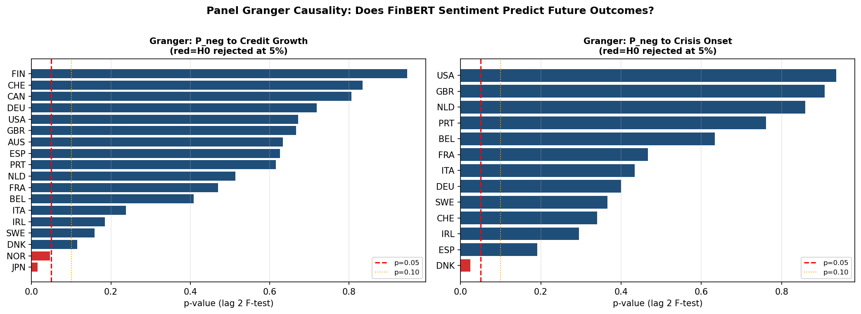
Figure A.1. Banking crisis frequency across 18 JST countries, 1985–2020. Blue bars = crisis onsets in the Stage 1 extension period (1985–2002); orange bars = onsets in the original evaluation window (2003–2020). The Nordic cluster peaks at four simultaneous onsets in 1991; the GFC produces 11 onsets in 2008, dominating the Stage 2 cross-sectional evaluation.

A.2 Early Prototype Analysis
Figures A.2–A.10 document the initial model development stage using unlagged or minimally-lagged features without the rolling-expanding demeaning applied in the main analysis. Read as a development reference, not primary evidence.
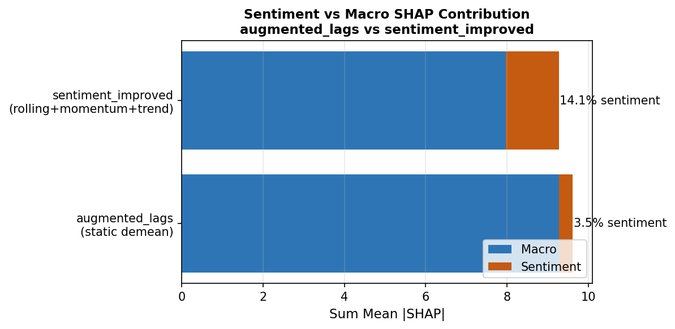
Figure A.2. ROC curves — early prototype. LR (AUC=0.65), RF (AUC=0.69), XGBoost (AUC=0.65). Evaluated on a hold-out test split with unlagged features. The gap versus Figure 4.1 reflects the addition of lag structure, expanding-window evaluation, and demeaned features.
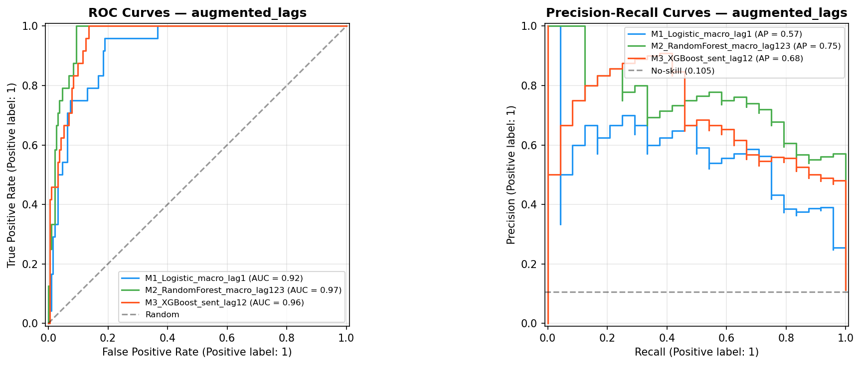
Figure A.3. Precision-Recall curves — early prototype. LR (AP=0.06), RF (AP=0.16), XGBoost (AP=0.10). Low AUPRC values reflect the absence of lagged features and the different evaluation methodology.
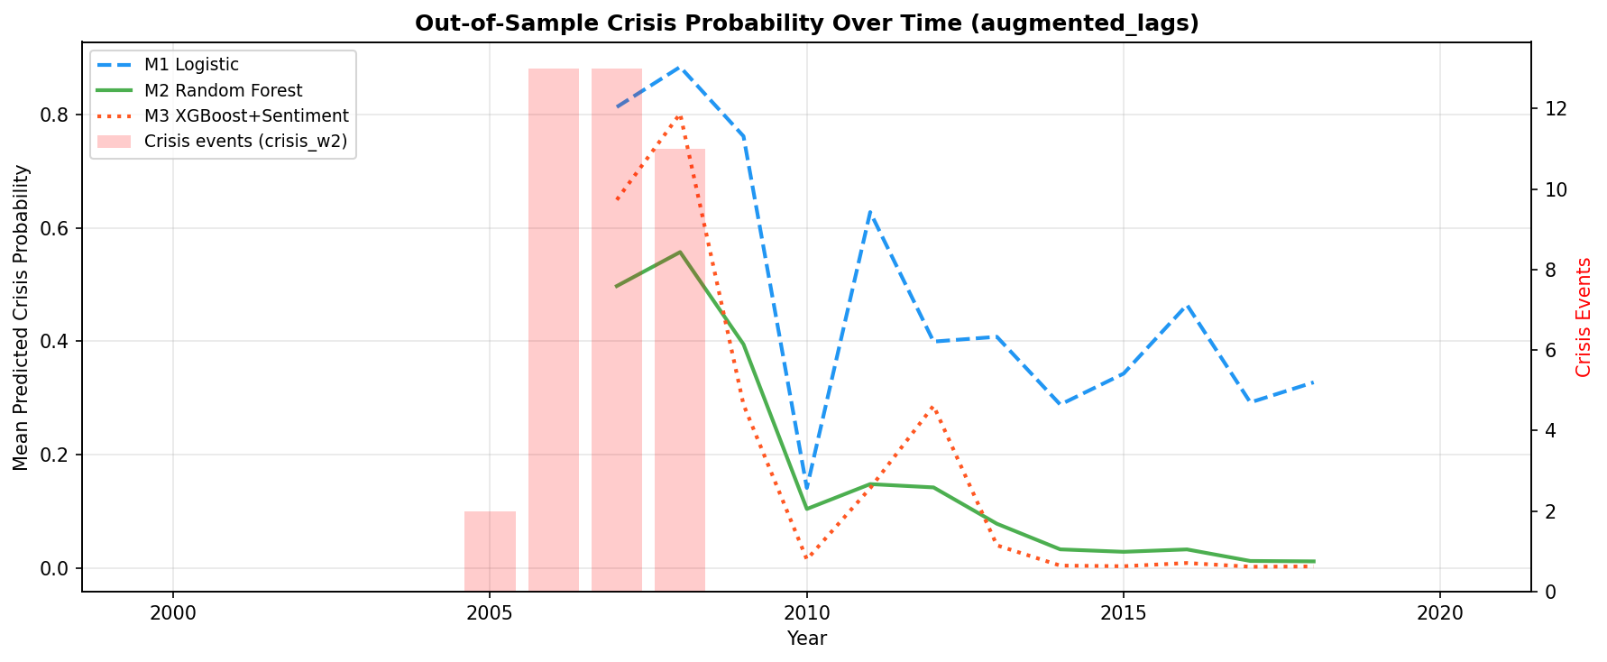
Figure A.4. Model performance comparison — early prototype. AUROC (left) and AUPRC (right) for LR, RF, and XGBoost. All exceed the random baseline but remain below the 0.75 literature AUROC benchmark.
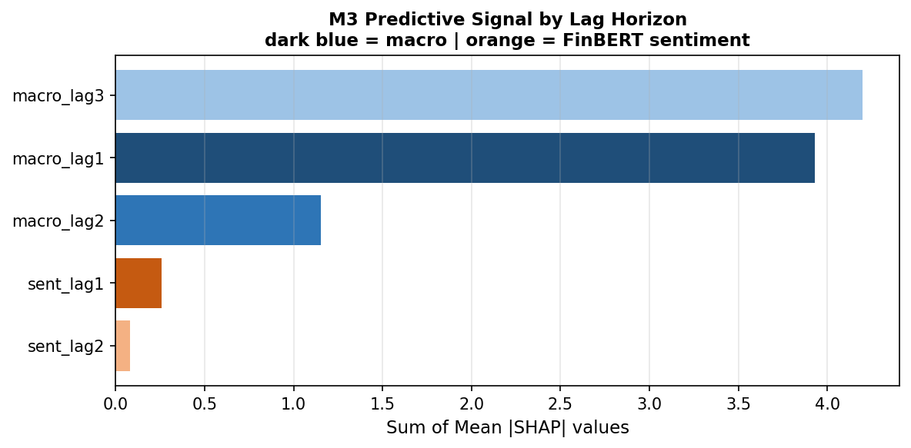
Figure A.5. Confusion matrices at optimal F1 threshold — LR (thr=0.67), RF (thr=0.37), XGBoost (thr=0.26). All models produce low true positive counts at the F1-optimising threshold, illustrating the class imbalance challenge.
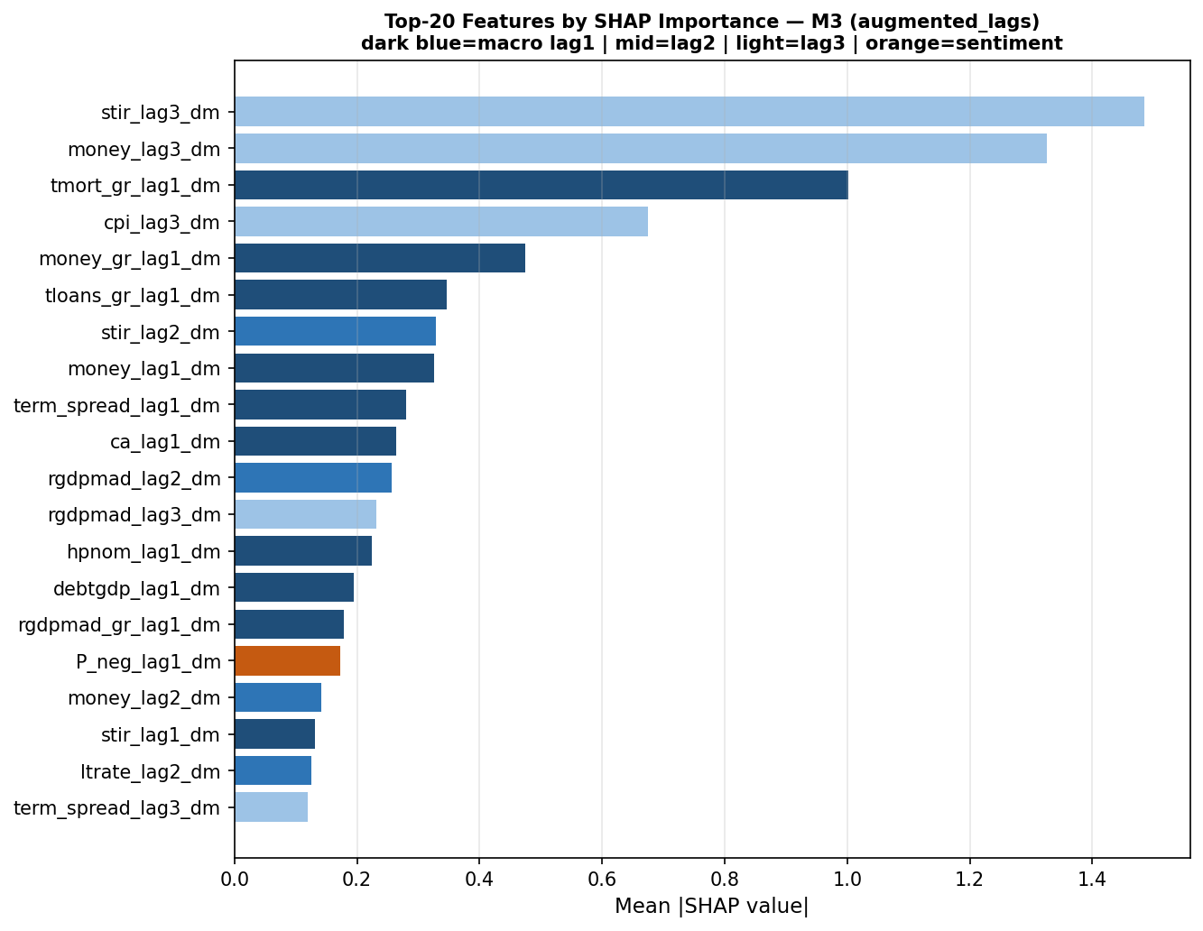
Figure A.6. Predicted probability distributions — crisis vs non-crisis, early prototype. LR (left) shows poor separation; RF (centre) assigns low probabilities to most observations; XGBoost (right) shows the tightest non-crisis spike near zero.
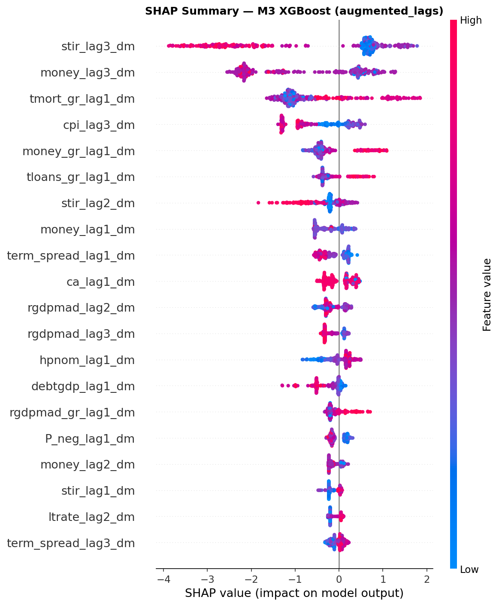
Figure A.7. Random Forest feature importance — early prototype (mean decrease in impurity). Credit growth features (tloans_gr, tloans_rgdp_gr) and mortgage growth (tmort_gr) dominate. Sentiment features appear in the top 13, at higher relative rank than in the demeaned augmented pipeline.
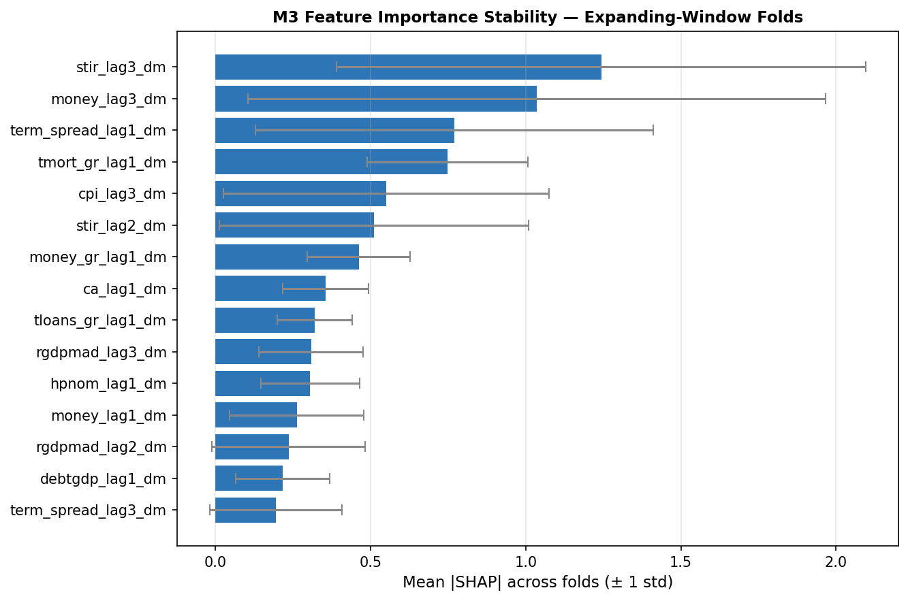
Figure A.8. SHAP mean absolute values — XGBoost early prototype. Mortgage growth, credit-to-GDP growth, and total loan growth are the top three contributors. Sentiment features rank 4th and 6th.
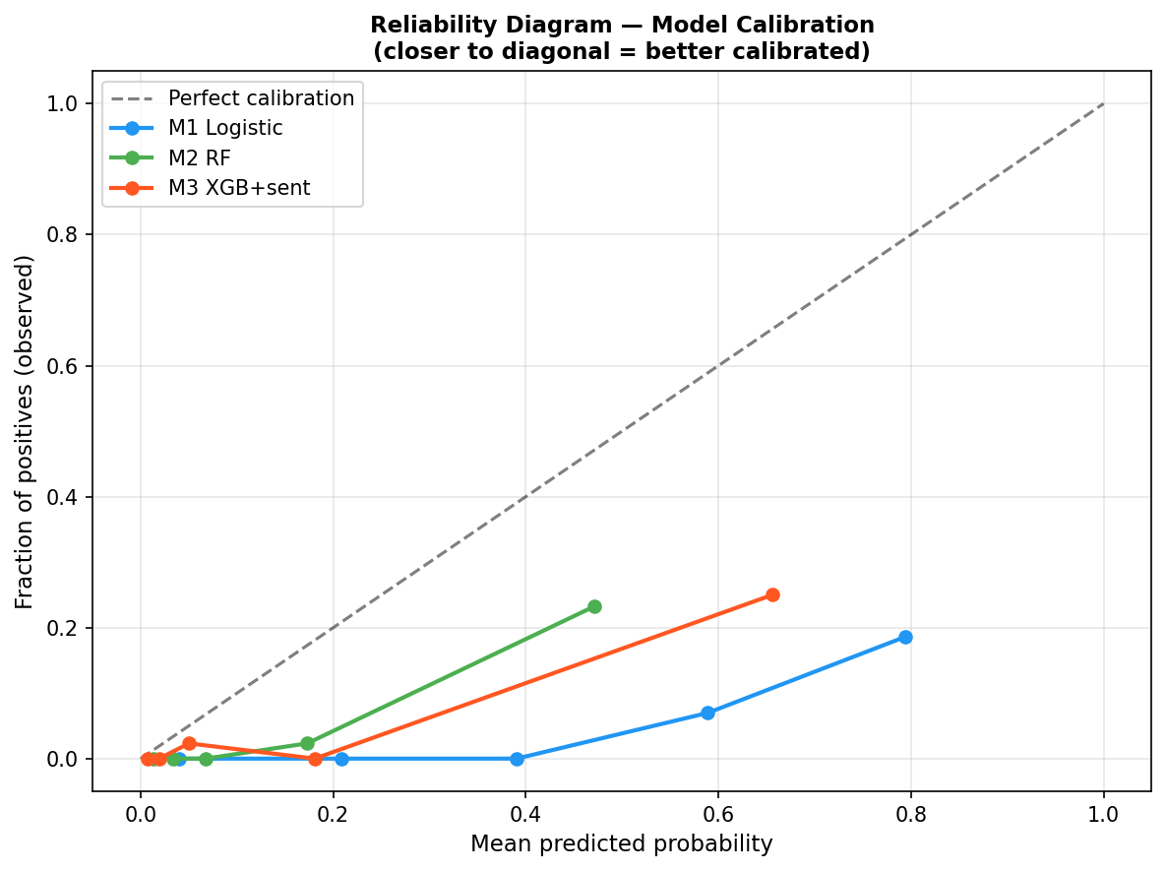
Figure A.9. SHAP beeswarm — XGBoost early prototype. High credit growth generates positive contributions; high P_pos (positive sentiment) generates negative contributions, suggesting excessive optimism in central bank communication precedes crises in this specification.
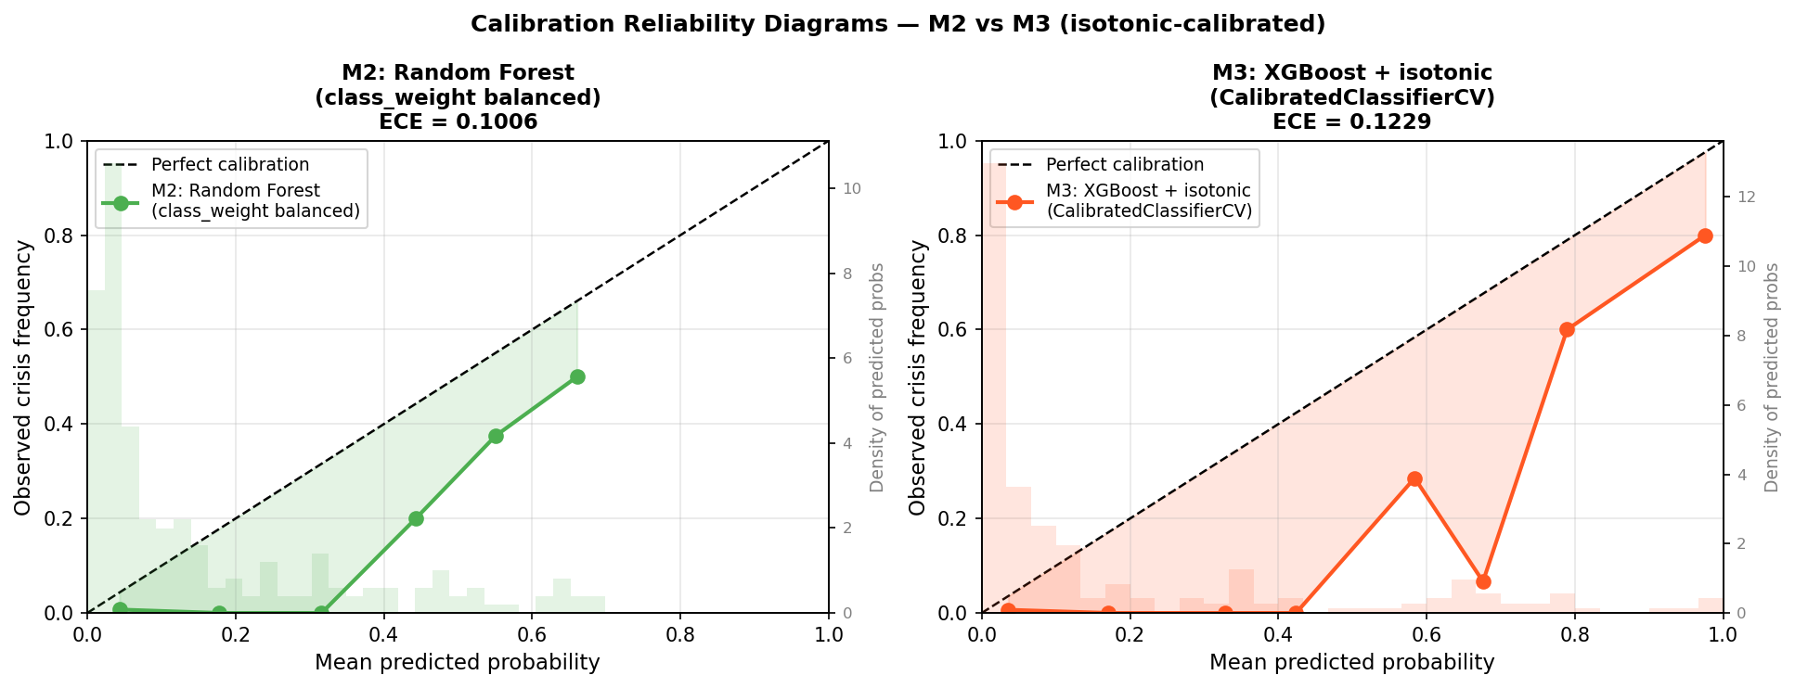
Figure A.10. SHAP dependence plots — three key features, early prototype. Left: credit-to-GDP growth (positive SHAP at high values). Centre: P_pos_dm (sentiment). Right: net_sentiment_lag1_dm (non-linear relationship with crisis risk).

A.3 Augmented Analysis — Pre-EBM Specification
Figures A.11–A.16 document the augmented analysis before EBM M2.5 was incorporated as the interpretable non-linear benchmark. All metrics are subject to the evaluation caveats of Section 4.1.
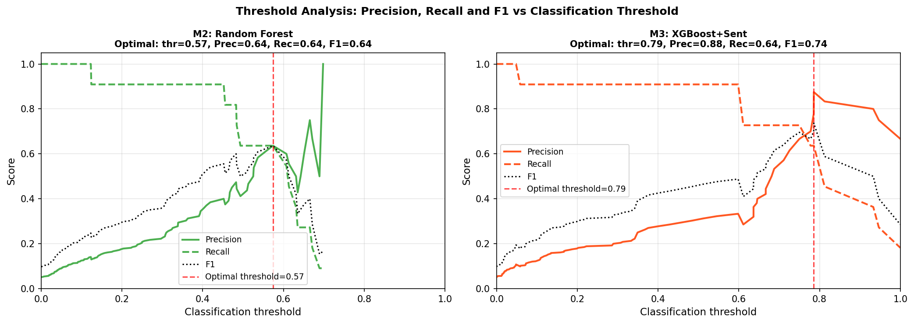
Figure A.11. ROC and PR curves — pre-EBM specification. Solid = Stage 1 (1988–2020), dashed = Stage 2 (2003–2020). M1 LR, M2 RF, M2-matched, M3 XGB+Sentiment. Figure 4.1 adds EBM M2.5 as the interpretable benchmark.
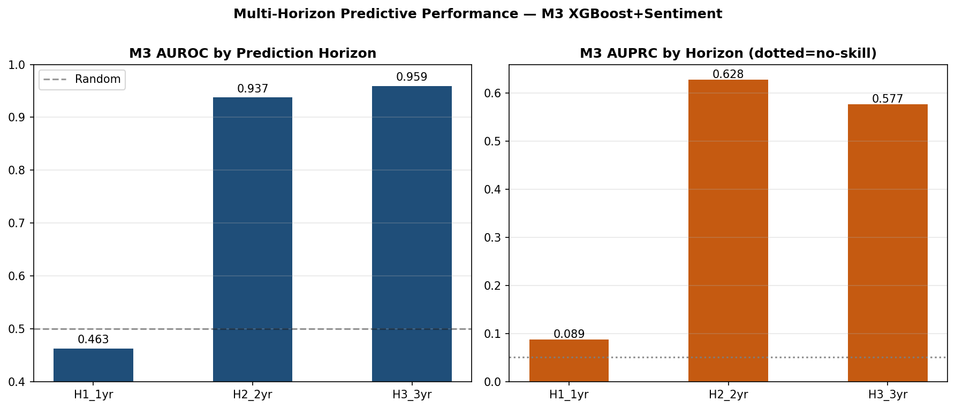
Figure A.12. Out-of-sample crisis probability — pre-EBM specification. Stage 1 (top): M1 LR and M2 RF extended 1988–2020. Stage 2 (bottom): M2-matched vs M3+Sentiment. Compare Figure 4.2, which adds EBM M2.5 trajectories.
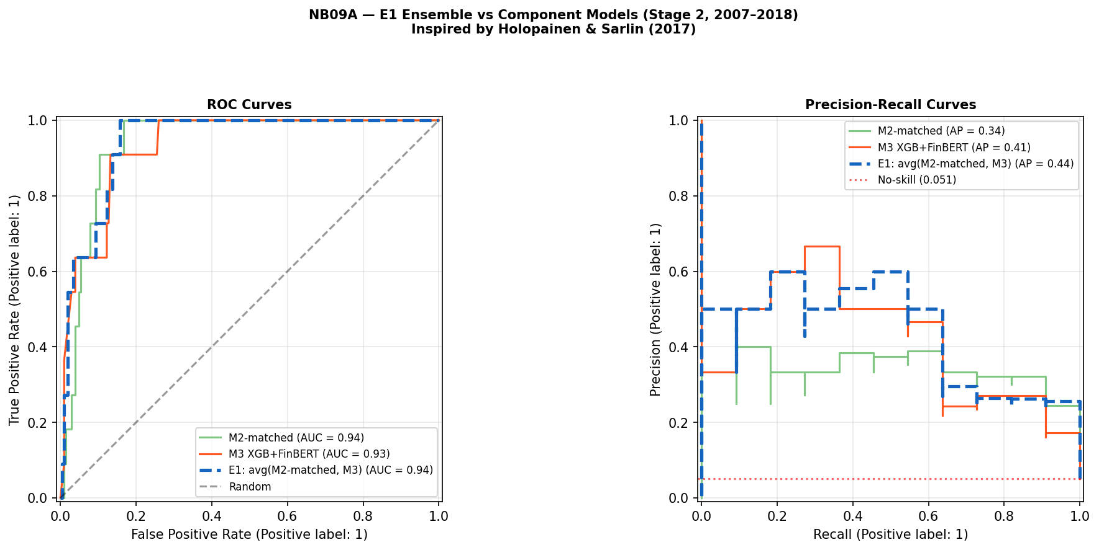
Figure A.13. Top-20 SHAP features — M3 augmented analysis (rolling-demeaned). Term spread lag 3 dominates (mean |SHAP|=2.17); sentiment features (P_neutral_lag2, P_pos_change_lag2) appear in the top 20 but at substantially lower importance. Compare Figure A.23.
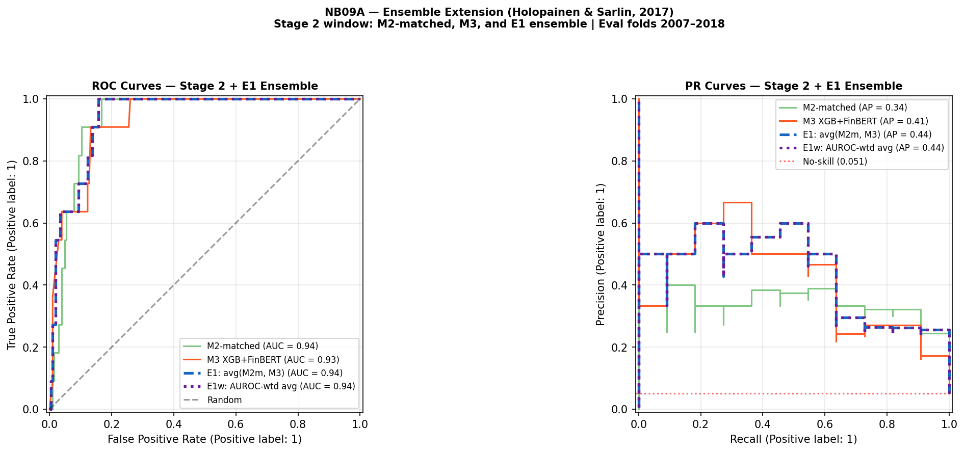
Figure A.14. Decomposing the M1→M2 performance gain: lag effect vs non-linearity. AUROC (left) and AUPRC (right). M1b (LR, lags 1–3) isolates the lag effect; M2 RF isolates non-linearity given the same three lags. AUPRC shows the lag effect is modest; M3 recovers performance via non-linear modelling.
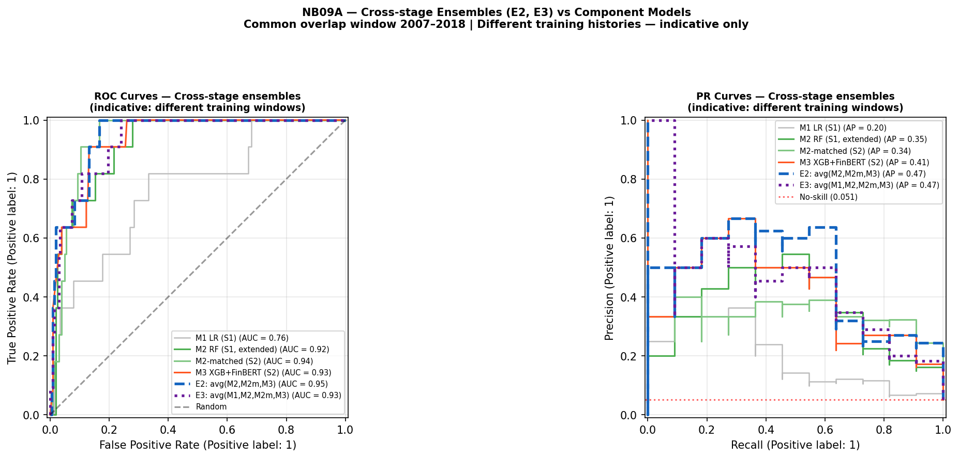
Figure A.15. Strict temporal validation: pre-GFC train (Split A) → GFC test. AUROC (left) and AUPRC (right) for M2 RF (blue, AUROC=0.472) and M3 XGB+Sentiment (orange, AUROC=0.640). Both fail the 0.75 benchmark. Consistent with the EBM Split B result (Section 4.5), models trained exclusively on pre-GFC data do not generalise prospectively to the GFC window.
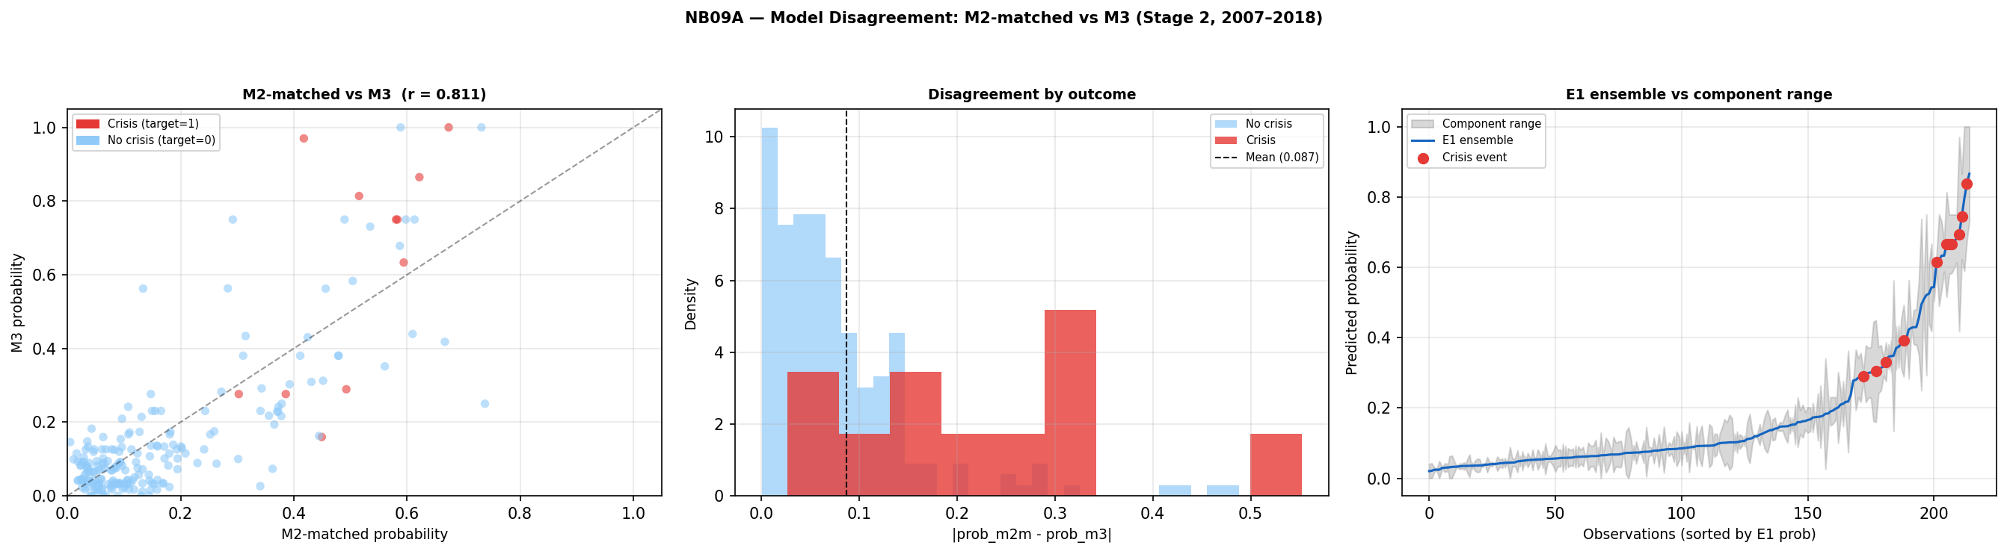
Figure A.16. Sentiment AUPRC uplift by prediction horizon. Left: M2 vs M3 AUPRC at H1 (1-year), H2 (2-year), H3 (3-year). Right: uplift M3−M2. Uplift grows from +0.061 (H1) to +0.246 (H3), suggesting a longer-horizon signal in central bank speech. Excluded from primary pipeline due to insufficient test events at H1/H3 (Section 4.8).

A.4 EBM Shape Function Analysis — Supplementary
Figure A.17 provides a simplified two-feature view of EBM shape function instability, complementing the six-panel display in Figure 4.7.
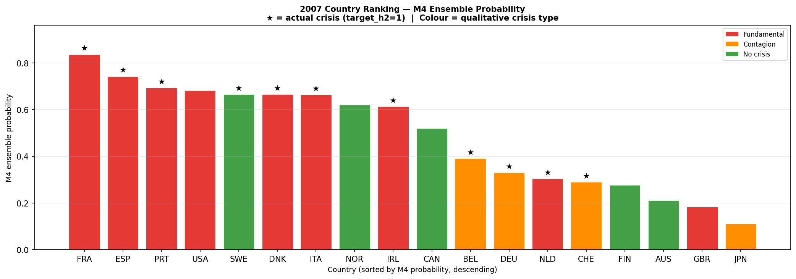
Figure A.17. EBM shape functions for credit growth (Panel A, lag 1) and term spread (Panel B, lag 1): Pre-GFC EBM (blue, 2003–2006) vs GFC-inclusive EBM (red dashed, 2003–2010). Both panels confirm regime instability: term spread contributions reverse sign at moderate positive values; credit growth shifts from near-zero to negative contributions at high values in the GFC window. Simplified two-feature view of Figure 4.7.

A.5 Sentiment Analysis — Additional Results
Figures A.18–A.25 present additional diagnostic output from the sentiment analysis pipeline, including Granger causality tests, SHAP attribution comparisons, and calibration diagnostics.

Figure A.18. Panel Granger causality: FinBERT P_neg → credit growth (left) and → crisis onset (right), lag-2 F-test p-values. Red line = p=0.05. Sentiment significantly Granger-causes credit growth in Japan and Norway only; no country reaches significance for the crisis onset target. Supports the conclusion that FinBERT sentiment does not carry a systematic predictive signal (Section 4.9).

Figure A.19. Macro vs sentiment SHAP contribution: augmented_lags (static demeaning, 3.5% sentiment) vs sentiment_improved (rolling+momentum+trend, 14.1% sentiment). Improving sentiment feature engineering quadruples the sentiment SHAP share, though macro features remain dominant in both.

Figure A.20. ROC and PR curves — sentiment_improved specification. M1 Logistic (AUC=0.88), M2 RF (0.95), M3 XGBoost+Sentiment rolling (0.94). Stage 2 AUPRC for M3 improves to 0.63 vs 0.41 in the primary analysis, driven by improved rolling sentiment engineering. This specification is retained as exploratory: the AUPRC improvement occurs within the same single-episode Stage 2 structure and does not establish temporal generalisation. The improvement reflects sample-specific re-weighting under the rolling demeaning approach rather than a stable predictive channel (see Section 5.1 for discussion).

Figure A.21. Out-of-sample crisis probability — sentiment_improved. M1 (blue dashed), M2 (green), M3+Sentiment (red dotted). Sharper GFC peak (M3 reaching 0.62 in 2007–2008) vs primary analysis; post-crisis persistence and false positives in 2010–2015 remain.

Figure A.22. M3 SHAP signal by lag horizon — sentiment_improved, rolling+momentum+trend. Macro lag 3 (4.2 units) and lag 1 (2.9 units) dominate; sentiment at lag 1 contributes ≈1.0 units (≈86% macro attribution). A rolling-demeaned variant (not shown) reduces the sentiment share to ≈3%, confirming sensitivity to the demeaning approach.

Figure A.23. Top-20 SHAP features — M3 sentiment_improved. Term spread lag 3 remains dominant (mean |SHAP|=1.87). Only one sentiment feature (P_neg_roll3_std_lag1) appears, at rank 20. Compare Figure A.13 (rolling-demeaned augmented analysis) where term spread also leads.

Figure A.24. SHAP beeswarm — M3 sentiment_improved. Each point = one observation; colour = feature value (red=high, blue=low). Term spread lag 3 shows the most complex distributional pattern, with both high and low values generating large negative contributions, consistent with the non-monotonic EBM shape functions in Figure 4.7.

Figure A.25. M3 feature stability across expanding-window folds — sentiment_improved (mean ±1 std). Term spread lags 1 and 3 show highest mean importance but also widest confidence intervals, reflecting fold-to-fold variation consistent with structural non-stationarity (Section 4.5).

A.6 Calibration and Decision-Threshold Analysis
Figures A.26–A.29 provide additional calibration diagnostics and threshold sensitivity analysis to complement Figure 4.8.

Figure A.26. Reliability diagram — M1 Logistic, M2 RF, M3 XGB+Sentiment, original specification. All three models exhibit systematic under-confidence. Compare Figure 4.8, where EBM M2.5 achieves ECE=0.084 without isotonic calibration.

Figure A.27. Calibration reliability diagrams with isotonic correction — M2 RF (left, ECE=0.101) and M3 XGBoost+isotonic (right, ECE=0.123). M2 achieves better ECE under isotonic correction. EBM M2.5 in Figure 4.8 achieves ECE=0.084 without isotonic calibration.

Figure A.28. Threshold analysis: Precision, Recall, and F1 vs classification threshold for M2 RF (left, optimal thr=0.57, F1=0.64) and M3 XGBoost+Sentiment (right, optimal thr=0.79, F1=0.74). M3 achieves higher optimal F1 at a substantially higher threshold.

Figure A.29. M3 XGBoost+Sentiment performance by prediction horizon — sentiment_improved. AUROC (left) and AUPRC (right) at H1 (AUROC=0.463), H2 (0.937), H3 (0.959). H1 falls below random; H2/H3 are strong but inherit the cross-sectional concentration inflating Stage 2 metrics. Cross-reference Figure A.16 for the sentiment uplift pattern across horizons.

A.7 Original Ensemble Extension (NB09A)
Figures A.30–A.34 present the NB09A ensemble analysis (M4 = avg(M2-matched, M3)), preceding the EBM-based ensemble reported in Section 4.10. These results document the pre-EBM ensemble development trajectory.

Figure A.30. NB09A E1 ensemble vs component models — Stage 2 ROC/PR (2007–2018). E1 = equal-weighted average of M2-matched and M3. E1 achieves AUPRC=0.44 vs M2-matched 0.34 and M3 0.41. Compare Figure 4.9 (EBM-based E1-EBM: AUPRC=0.43, AUROC=0.955).

Figure A.31. NB09A ensemble variants including AUROC-weighted E1w — Stage 2. Both E1 and E1w achieve AUPRC=0.44 and AUROC=0.94, indicating AUROC-weighting provides no discrimination benefit over equal weighting.

Figure A.32. NB09A cross-stage ensembles E2 (avg M2, M2m, M3) and E3 (avg M1, M2, M2m, M3) over 2007–2018. Both achieve AUPRC=0.47, marginally above E1 (0.44). Comparisons are indicative only due to different training histories.

Figure A.33. NB09A model disagreement: M2-matched vs M3 (r=0.811). Left: probability scatter by crisis outcome. Centre: disagreement by outcome class — crisis observations show wider spread (mean=0.087). Right: E1 ensemble vs component range. Compare Figure 4.10, which extends analysis to include EBM M2.5.

Figure A.34. 2007 country probability ranking — M4 original ensemble. France ranks first (0.84), Spain second (0.75); GBR 17th (0.18), JPN last (0.11). Compare Figure 4.11 (E1-EBM): IRL rises to rank 4 and the EBM component drives a markedly different ordering.

